**Cuyahoga County**



**Infor CRM 8.3 Pilot**

**Blueprint**

|  |  |
| --- | --- |
| Author | Valerie Parker |
| Date | December 20, 2017 |

Table of Contents

1 InforCRM Blueprint 4

1.1 Blueprint Overview 4

1.2 InforCRM Security 5

1.3 Blueprint Success Factors 5

1.4 Implementation Roles Overview 5

1.5 Implementation Roles Defined 6

2 Project Objectives 7

3 InforCRM Users 8

3.1 User Overview 8

3.2 InforCRM User Templates 9

3.3 InforCRM Users 10

3.4 Your Security Needs 11

3.5 InforCRM Teams 11

3.6 InforCRM Roles 13

3.7 Calendar Security 13

4 InforCRM Module Screenshots 19

4.1 Menu Navigation 20

4.1.1 HHS Nav Bar 20

4.1.2 DoD Nav Bar 20

4.2 Accounts 21

4.2.1 Out of the box Account comfigurations 21

4.2.2 Customized Accounts module 21

4.2.3 Account Groups 29

4.3 Contacts 31

4.3.1 Out of the box Contacts Configurations 31

4.3.2 Customized Contacts module 32

4.3.3 Contact Groups 39

4.4 Opportunities 42

4.4.1 Out of the box Contacts Configurations 42

4.4.2 Customized Opportunities module 42

4.4.3 Opportunity Groups 48

4.4.4 Sales Processes 48

4.5 Custom County Sites Entity 59

4.5.1 County Sites main view 59

4.6 Custom Skills/Credentials Entity 62

4.6.1 Credentials main view 62

4.7 Activities 64

4.8 Tickets 65

4.8.1 Out of the box Ticket configurations 65

4.8.2 Area Category Issue 66

4.8.3 Customized Ticket module 70

4.8.4 Ticket Groups 79

4.9 Advanced Groups and Dashboards 81

5 Email and Outlook integration 83

6 Data Import 83

7 Approval 84

8 Change Log 84

# InforCRM Blueprint

InforCRM has a set of core components which are the cornerstones in which a CRM project is implemented. These components may be configured to construct the InforCRM application specific to your company’s needs.

Your company’s specific and unique business processes are captured and communicated using the InforCRM Blueprint. The Blueprint serves as an agreement and understanding of how InforCRM is to be initially configured by Technology Advisors for your implementation.

The following section provides an overview of the sections that will be completed, specific to your business needs, as well as some tips for completing the Blueprint.

## Blueprint Overview

The following areas must be configured to ensure that InforCRM is a viable business tool for your organization:

***Implementation Personnel***

* Who will be performing what task for planning and implementation

***InforCRM Users***

* Defines the users of the system
* User IDs and passwords, etc.
* Calendar security provides the rules of viewing and editing other users’ schedules
* ‘Reports to’ hierarchy

***InforCRM Module Screen Shots***

* Defines any changes, quantified by your Statement of Work, to the Account, Contact, Opportunity Detail, Ticket, Defect, Contract, Return, Lead and Campaign Detail tabs for your organization. Includes any changes, quantified by your Statement of Work, to the pick list/dropdowns values to be specific for your business process for the above entities

***Disables Modules***

* Defines any entities your Company choses to have hidden from users’ view if critical to your business needs.

***Data Import***

* Included based on your Statement of Work
* Defines how your existing data will be imported into InforCRM
* Also used to define record ownership/team security

***Data Integration***

* Included based on your Statement of Work
* Defines how your existing systems will interface with InforCRM on an ongoing basis

## InforCRM Security

* InforCRM’s security is based upon Account Ownership
* If users have access to a specific Account record, by default they have access to that Account’s associated Contact, Opportunity, Ticket, Defect, Contract, Lead and Campaign records
* NOTE – if this is not part of your implementation, the security is defaulted to “Everyone”, which allows for all users to access all accounts and their associated records

## Blueprint Success Factors

In completing this Blueprint, Technology Advisors has a few tips:

* Technology Advisors recommends that you have one key decision maker who is responsible for resolving conflicts that arise when multiple opinions are provided.
* You may wish to request input from other key individuals/groups from your organization.
* Prior to approving the Blueprint with your TAI Project Team, you will need to consolidate all copies of the Blueprint that people in your organization may have been working on.

## Implementation Roles Overview

Implementing InforCRM requires you to designate individuals from your organization for four key roles: Project Manager, Technical Representative, InforCRM Administrator, and Business Subject Matter Expert The following sections describe these roles and allow you to designate these key individuals.

***Client Project Manager:***

* The Client Project Manager works closely with the TAI Project Team to ensure each task is completed properly and on-schedule. If issues arise, the Project Manager will discuss and mutually agree on a suitable solution with the TAI Project Team.

***Client Technical Representative:***

* The Technical Rep is responsible for the related hardware and system software, such as the company’s SMTP servers. The Technical Rep should have skill sets with Microsoft Networking and database administration.

***Client InforCRM Administrator:***

* The InforCRM Administrator is responsible for the maintenance and security of the InforCRM system. The Administrator will assist the TAI Project Team with information required for setup and configuration of InforCRM during the implementation, and take over the administration role post implementation.

***Client Business Subject Matter Expert (SME):***

* The Business SME(s) is responsible for providing and representing the business needs of Company throughout the project, particularly during the Joint Design/Development Sessions. The SME(s) will fully test the InforCRM system during the User Acceptance Test process and identify issues and concerns that are not aligned with the stated and approved business requirements.

## Implementation Roles Defined

Please provide details about the individuals from your organization who will fulfill the roles described above. Depending on your business, these roles may or may not be filled by the same person.

**Client Project Sponsor**

Name: Jim Hay

E-mail: [jhay@cuyahogacounty.us](mailto:jhay@cuyahogacounty.us)

**Client Project Manager**

Name: Ursula Kaunas / Deb Hart

Email: [ukaunas@cuyahogacounty.us](mailto:ukaunas@cuyahogacounty.us) / [Deborah.quayle-hart@jfs.ohio.gov](mailto:Deborah.quayle-hart@jfs.ohio.gov)

**Client Technical Representative**

Name: Keith Kozer

Email: [kkozer@cuyahogacounty.us](mailto:kkozer@cuyahogacounty.us)

**Client InforCRM Administrator**

Name: TBD / Russ Jenkins

Email: [TBD@cuyahogacounty.us](mailto:TBD@cuyahogacounty.us) / [russell.jenkins@jfs.ohio.gov](mailto:russell.jenkins@jfs.ohio.gov)

# Project Objectives

This section gives an overview of the expectations of the final InforCRM implementation, allowing the project team to ensure configurations and customizations are focused on the goals of the project. The main project objectives are:

* Increase understanding of the Infor CRM platform’s capabilities, for informing future projects’ scope;
* Replace one or more existing contact management solutions that are ‘stand alone’ with basic contact management functionality;
* Deploy capabilities into one or more units where no automated CRM exists today.

# InforCRM Users

The following section gives an overview of what is required for a user and requires input regarding your InforCRM users, teams, roles and calendar security.

## User Overview

This is a screenshot of the standard User Detail web setup screen. This user profile information allows InforCRM users to log onto the system. Each user in the system must be associated with a license selected in the User Type field. Notice the license counts in parenthesis under the User Type field on the screen shot below.

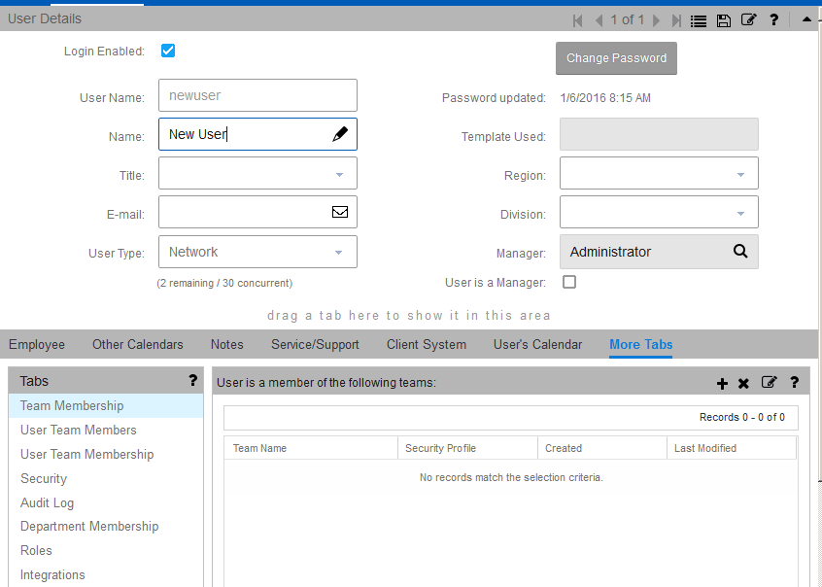

The Details screen and other tabs define user fields and other helpful information. The required fields are marked with *.

**User Name\***: The user name that the user logs into the system with. **(NOTE – periods (.) are not to be used as part of the user name).**

**Name:** The InforCRM user’s first and last name

**Title:** Used for mail merges and templates.

**Email:** Used for receiving system notification and email merge.

**User Type*:** The type of access the user has. Users are either “Network” or “Concurrent”, where “Network” is the default.

**Template Used:** Enter the Template name if you want to create this user based on an existing template.

**Region:** A field for classifying users based on business practices.

**Division:** A field for classifying users based on business practices.

**Manager*:** Each User must report to another user in the system (or to the ‘Admin’ user which is the default). This is used for security of account hierarchies.

**User is a Manager**: Indicates the user is a manager for account hierarcy/security purposes.

**Additional information helpful for security and functionality access:**

**Department**: A field (on tab Department Membership) for classifying users based on business practices.

**Roles**: See section 3.6 below.

**Team Membership**: See section 3.5 below.

**Security Profile**: See section 3.5 below.

## InforCRM User Templates

User templates define attributes such as Department and Region, company address information (used for mail merge templates), security, team access, and other information. User templates are used to create a basis for similar types of users, rather than having to create each user from scratch. User templates have a one-time association to a user. If a user template is updated after a user is created, the user properties are not automatically updated. Please work with your TAI Project Team to define the user templates for your implementation.

## InforCRM Users

Please list your InforCRM users in the table below and provide details for all of the columns listed. If you need help with the columns, please refer to the table on the previous page or contact your TAI Project Team. Your SOW defines the number of users that TAI will set up as a part of your implementation. Any additional users will need to be purchased and set up by your InforCRM Administrator. It is best practice to set up the highest ranking managers first so their user name can be specified as managers during setup of their subordinates.

|  |  |  |  |  |  |  |
| --- | --- | --- | --- | --- | --- | --- |
| First Name | Last Name | UserName | User Type | Department | User’s Manager | Email |
|  |  |  |  |  |  |  |
|  |  |  |  |  |  |  |
|  |  |  |  |  |  |  |
|  |  |  |  |  |  |  |
|  |  |  |  |  |  |  |
|  |  |  |  |  |  |  |
|  |  |  |  |  |  |  |
|  |  |  |  |  |  |  |
|  |  |  |  |  |  |  |
|  |  |  |  |  |  |  |

**Reccomended Initial Password for all users: Password1**

NOTE - This password can, and is encouraged to, be reset by the users once they sign in for the first time.

## Your Security Needs

You have provided the following security and functionality requirements. In the subsequent sections, we will define how these requirements will be implemented via Infor Teams, Security Profiles and Roles. Additionally, restrictions on the ERP Customer ID field are discussed in the customization section under Accounts.

**Security Needs:**

| Department Name: **Accounting (Sample)** |
| --- |
| 1. Can view all accounts (no edit, add, delete). 2. Can create activities against any account. Can edit their own activities. 3. Cannot delete, import, export on any module. |

| Department Name: **Sales (Sample)** |
| --- |
| 1. Can view all accounts (no edit, add, delete). Note: this means that ***Sales cannot convert Leads to Accounts since that is the Account ADD function***. 2. Can edit their own accounts by territory. 3. Cannot add/edit ERP Customer ID on any account. 4. Can create activities against any account/contact/opportunity. Can edit their own activities. 5. Cannot delete, import, export on any module. |

## InforCRM Teams

Account Ownership defines which users can access that account. Accounts can be owned by a User, by a Team, or by Everyone. The system default is that all accounts are owned by Everyone, which allows all users access to all accounts. If a Team is set as the Account Owner, only members of that team have access/visibility to the account. Teams can consist of users, departments, and other teams. You might create teams based on region, territory, type of account, or department.

Security Profiles add data action restrictions to a user’s membership on a specific team and can be defined per user per team. Users can belong to more than one team and their security profiles can be different for each team. For example, user Mary works in Territory North but also needs to see the accounts in Territory South. We would add Mary to Team North with a Security Profile of Read/Write. We would add Mary to Team South with a Security Profile of Read Only. Additionally, any user can create an activity against an account even if their Security Profile is Read Only for that account.

**Security**

What types of account security will be utilized?

Individual User

Team  *(If selected, please define teams and security profiles below)*

Everyone

Everyone (Read Only)

**Team and Security Profile Definition:**

Generally, users in the Management and Customer Service departments will have no restrictions set on any of their team Security Profiles. This will allow them to have add/edit capabilities to all accounts. And because they can add accounts to any team, they would not have a default team in their user profile.

Generally, users in the Accounting department will have the Read Only restriction set for all Teams. This will ensure they can only view accounts, not add/edit accounts.

| Team Name: **UNASSIGNED (Sample)** |
| --- |
| Team Description: Unassigned Accounts team.   1. Only Customer Service and Management users are members of this team. 2. Customer Service and Management users have this team as the default Owner on their user profile. 3. Customer Service and Management Users are set up with the Read-Write Security Profile for this team. 4. The purpose of this team is a placeholder until an appropriate Team is selected for an account. |

| Team Name: **CAN1 (Sample)** |
| --- |
| Team Description: CAN1 Territory team.   1. All users are members of this team. 2. Sales users needing edit access have this team as the default Owner on their user profile. 3. Users needing edit access are set up with the Read-Write Security Profile for this team. 4. Users needing view only access are set up with the Read Only Security Profile for this team. |

## InforCRM Roles

Infor CRM uses Roles to remove functionality from what a regular user can do in the overall system, such as access to entire modules, or create, edit, delete, import and export records of all types. A user can be assigned to more than one role, and the least restrictive role takes precedence.

The Standard User Role is a basic Role which allows access to all standard user features and functions (it does not allow access to Admin type functions). It is best practice to assign this Role as a default if no other customized Role is applicable and to NOT modify this Standard User Role.

Reports in Infor do allow export of the report by default so the report can be used for business purposes outside the Infor system. If this export must be restricted, then the user will not be allowed any access to reports at all.

**Role Definitions:**

| Role Name: **Accounting (Sample)** |
| --- |
| Role Restrictions:   1. No delete any records on any module 2. No add any records on any module 3. No import, no export any records on any module 4. Can create activities against any account. Can edit their own activities. |

| Role Name: **Sales (Sample)** |
| --- |
| Role Restrictions:   1. No delete any records on any module 2. No add any records on any module This also means that ***Sales cannot convert Leads to Accounts since that is the Account ADD function***. 3. No import, no export any records on any module 4. Can create activities against any account/contact/opportunity. Can edit their own activities. |

## Calendar Security

Calendar security allows one user to create/modify Activities for someone else’s calendar. For example an administrative assistant could setup a meeting for a manager so the Manager has nothing to do but see her activities and close them out. Or an inside sales person could setup a meeting on behalf of an outside sales person. So the person needing to do this would need access to the other person’s calendar and also have the appropriate permissions (add/edit/delete etc.).

Your system Administrator can set calendar access rights for each individual user.

|  |  |  |  |  |  |  |
| --- | --- | --- | --- | --- | --- | --- |
|  | User | View Calendar | Add to Calendar | Edit Calendar | Delete from Calendar | For these users |
| 1 | John Smith | x | x | x | x | All Users |
|  |  |  |  |  |  |  |
|  |  |  |  |  |  |  |
|  |  |  |  |  |  |  |
|  |  |  |  |  |  |  |
|  |  |  |  |  |  |  |

This is based upon all recent discussions and recent decisions through Friday, 2/2, 2:00CT . Please note, in the User Rights & Roles Templates:

* the ONLY Teams that should have a separate column in the spreadsheet are those listed as Teams below
  + Teams are used to define what account records a user has access to; if they don’t have access to the account they have no knowledge of any record attached to that account
  + Teams are used to group users for ease of maintenance
* the ONLY Roles that should have a separate column in the spreadsheet are those listed as Roles below
  + Roles are used to define what *secured* functionality, menu items, tabs, or fields a user has special access to
* Users on each Team and within each Role should be indicated on the User Rights & Roles Template

**Teams**

* CC All Team
  + Default Owner of all non-HHS specific account and contact records
  + Members include:
    - DoD All team
    - WI All team
* DoD All Team
  + Would NOT be a record Owner
  + Members include:
    - All DoD CRM Users
* HHS All Team
  + Default Owner of all HHS specific account and contact records
  + Members include:
    - Members of the CFS All Team
    - Members of the CFS Secure Team
    - Members of the JFS All Team

Members of the HHS Support Team

* HHS Support Team
  + Would NOT be a record Owner
  + Members include:
    - Designated HHS management
    - Designated HHS IT
    - Other designated HHS personnel who are CRM users and not already on an agency team
* CFS Secure Team
  + Owner of account/contact records only for specific sensitive issues ~~the~~
  + Members include:
    - Sherri, Steve & Deonna as noted on the User Rights & Roles Template
    - This is a subset of the CFS ALL team
* CFS All Team
  + Would NOT be a record Owner
  + Members include:
    - All CFS users as noted on the User Rights & Roles Template
* JFS All Team
  + Would NOT be a record Owner
  + Members include:
    - All JFS users (including those who administer aspects of WI/SkillUp) as noted on the User Rights & Roles Template
* WI All Team
  + Would NOT be a record Owner
  + Members include:
    - Only those HHS users who administer aspects of WI/SkillUp (Andrea Turi) as noted on the User Rights & Roles Template

**Roles**

DoD Role

* The only users who have access to the DOD Nav Bar menu
* The only users who can edit Account > CD Status
* The only users who can edit Account > SUP Status
* The only users who have access to the Account > Skillup tab
* The only users who have access to the Opportunity > Site tab
* The only users who have access to the County Sites entity
* Includes:
  + All users in the DoD All team

ED Status Role

* The only users who can edit Account > ED Status
* Includes:
  + as noted on the User Rights & Roles Template
  + Bryan Edwards
  + Greg Huth

SUP Role

* The only users who have access to the Opportunity > Skillup tab
* Includes:
  + All users in the DoD All team
  + All users in the WI All team

SkillCredential Entity Role

* The only users who have access to the Skills/Credentials entity
* Includes:
  + as noted on the User Rights & Roles Template
  + David Feinerman
  + Austin Gump

Opportunity Manager Role

* The only users who can edit Opportunity > Opportunity Manager
* Includes:
  + as noted on the User Rights & Roles Template
  + David Feinerman
  + Greg Huth
  + Ken Surrat
  + Paul Herdeg

HHS Role

* The only users who have access to the HHS Nav Bar menu
* The only users who have access to the Contact > HHS Detail tab
* The only users who can see the Ticket > Resolution Progress field
* The only users who can see the Ticket > Comments field
* Includes:
  + All users on the HHS All team

Library Role

* The only users who can add/delete library items/files
* Includes:
  + Valerie Baker, Sabrina Ingram, Deonna Kirkpatrick, Steve Rusnak, as noted on the User Rights & Roles Template
  + All users on the DoD All Team

Power User Role to disable the auto-time out

* We discussed this with Infor. There is no OOTB way to prevent users from changing or disabling their auto-time out.
* Infor was not able to suggest a method to customize to achieve the desired results, so it would take research on our part to know if it could be accomplished.

Read Only Role

* No add/update of accounts, contacts, tickets, opportunities, etc.
* There is no OOTB way to prevent users from changing information in the Address block. We discussed this with Infor.
* We are discussing with infor that Ticket > Description and Resolution is not R/O, but this is not a show stopper for HHS.
* Includes:
  + Those designated as Read Only Role on the User Rights & Roles Template

Export Role

* The only users who can Export data to Excel
* Includes:
  + JFS, CFS and PEI users as designated on the User Rights & Roles Template
  + Ted Carter
  + Greg Huth
  + David Feinerman
  + Kenneth Surrat
  + Paul Herdeg

Admin Role

The only users who have visibility to the HHSID field

HHSID field on Contact

**Functionality**

Entity record Delete restricted to Admin only

* No one other than System Admin can delete entity records (lead, account, contact, opportunity, ticket, skill, site)
* To request a record be deleted, users open a Ticket and assign to a System Admin
* The review and delete are performed by System Admin because care must be taken when deleting public records
* Note that any user can delete their own Note or Activity, thus this paragraph is NOT labeled as “Delete restricted to Admin only”
* There is no OOTB way to prevent users from deleting attachments. We discussed this with Infor.

Merge restricted to Admin only

* No one other than System Admin can merge records (only applies to accounts and contacts)
* To request records be merged, users will mark as Status = Duplicate, open a Ticket and assign to a System Admin;
* The review and merge are performed by System Admin because care must be taken when deleting public records

Import restricted to Admin only

Development of new Crystal Reports restricted to Admin only

* No one other than System Admin can develop new reports
* To request a report, users will open a Ticket and assign to a System Admin
* Report development is performed by System Admin because this is an IT programming effort with Crystal Reports software, requiring access to the system server and access to a System Admin userid/password

# InforCRM Module Screenshots

The following pages include details about selected forms in InforCRM. After the form description and screenshot, a wireframe is available to display the custom fields that your business requires.

**InforCRM Form Overview**The box below provides details for determining the appropriate data type for a custom field. It is recommended that you review the screenshots to determine if existing fields will meet your business needs. In most cases if the field is a pick list data type it is possible to add or change values.

If a custom field is to be added, the following is the key for the data type:

**Checkbox:** One character; usually a True (T) or False (F), or a Yes (Y) or No (N) entry

**Currency:** Used for storing monetary data

**Date:** Used to capture a calendar date

**Picklist:** Allows for the user to select from a series of preset values

**MultiSelect:** Allows for a user to select multiple values from a preset list

**Lookup:** Relates (creates a linkage between) one record to another Module/Record

**Memo:** Multi-line text box

**Text Field:** Single line text box

**Real:** A number with decimals

**Integer:** A number without decimals

## Menu Navigation

The standard left-side navigation (Nav) bar menu options can be easily configured for various groups of users. In addition to the Administration and Integration Nav bars which will be secured, Cuyahoga County will have 3 Nav bar menu choices at this time.

### HHS Nav Bar

Welcome

Accounts

Contacts

Tickets

Activities

Calendar

Library

What’s New

### DoD Nav Bar

Welcome

Leads

Accounts

Contacts

Opportunities

Tickets

Sites

Skills/Credentials

Activities

Calendar

Library

Reports

Standard Problems

Standard Resolutions

Area/Category/Issue

What’s New

## Accounts

Accounts refer to prospects or customers that you have a relationship with. They may cover a variety of different types, including prospects, customers, vendors, partners, competitors, etc.

### Out of the box Account comfigurations

The Account form is where Account records are profiled and where high-level information about the company is available at a glance. This is the “Out of the Box” configuration:

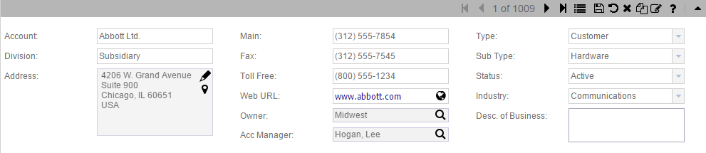

This is the “Out of the Box” Account Detail form:

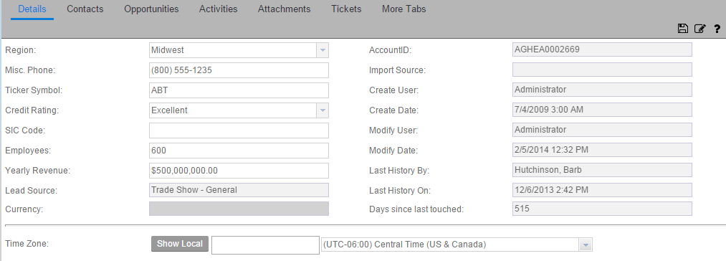

### Customized Accounts module

The goal for the County is to have one version of the account screen that all County agencies can use. Thefore, some pick lists may have values that do not pertain to one specific agency but would be used by another.

#### Field Definitionions

|  |  |  |  |
| --- | --- | --- | --- |
| **Field Name** | **Field Type** | **Values** | **Comments** |
| Legal Name | Text |  | New; under Account (name) |
| Account Type | Pick list | Business  Government  Individual  Non-Profit  Third-party Lender |  |
| Account SubType | Pick List | Local  Federal  State | Government |
| ED Status | Pick list | Active  Delinquent  In Collections  Inactive  Other | New field under Status;  Edit is secured to ED Status Role |
| CD Status | Pick List | Active  Delinquent  Demolition  Foreclosure  Funding  Inactive  Short Sale  Other | New field under ED Status;  Edit is secured to DoD Role |
| SUP Status | Pick List | Active  Inactive  Other | New field under CD Status;  Edit is secured to DoD Role |
| Industry | Pick List | Construction/Service  Education  Financial  Healthcare  Hospitality/Tourism/Rec  Human Services  Manufacturing  Municipalities  Professional Services  Retail  Sports/Entertain/Media  Staffing Services  Technology  Trans/Dist/Logistics  Utilities  Other | Replace existing list;  Same picklist as Lead > Industry |
| Division | Text |  | 1/17 Replace with Text |
| SBA Certification | Multi select picklist | Certified  Certified in CC  Disabled  Small Business  Veteran Owned  Women Owned | 2/7 David to provide values |
| Tax ID / TIN | text |  | New;  Add under Parent Account, above Council District |
| Region | Pick List | Council District -1  Council District -2  Council District -3  Council District -4  Council District -5  Council District -6  Council District -7  Council District -8  Council District -9  Council District -10  Council District -11  Not Applicable (N/A) | Move up to Account Main screen;  Relabel as Council District  Future Phase(s): Interface with Cuyahoga County GIS System to auto -populate District selection based off of zip code. |
| City | Pick list | |  |  |  |  |  |  |  |  |  |  |  |  |  |  |  |  |  |  |  |  |  |  |  |  |  |  |  |  |  |  |  |  |  |  |  |  |  |  |  |  |  |  |  |  |  |  |  |  |  |  |  |  |  |  |  |  |  |  |  |  | | --- | --- | --- | --- | --- | --- | --- | --- | --- | --- | --- | --- | --- | --- | --- | --- | --- | --- | --- | --- | --- | --- | --- | --- | --- | --- | --- | --- | --- | --- | --- | --- | --- | --- | --- | --- | --- | --- | --- | --- | --- | --- | --- | --- | --- | --- | --- | --- | --- | --- | --- | --- | --- | --- | --- | --- | --- | --- | --- | --- | | |  | | --- | | [Bay Village](http://www.cityofbayvillage.com/) | | [Beachwood](http://www.beachwoodohio.com/) | | [Bedford](http://www.bedfordoh.gov/) | | [Bedford Heights](http://www.bedfordheights.gov/) | | [Bentleyville](http://www.villageofbentleyville.com/) | | [Berea](http://cityofberea.org/) | | [Bratenahl](http://www.bratenahl.org/) | | [Brecksville](http://www.brecksville.oh.us/) | | [Broadview Heights](http://www.broadview-heights.org/) | | [Brook Park](http://www.cityofbrookpark.com/) | | [Brooklyn](http://www.brooklynohio.gov/) | | [Brooklyn Heights](http://www.brooklynhts.org/) | | [Chagrin Falls](http://chagrin-falls.org/) | | [Chagrin Falls Township](http://chagrinfallstownship.org/) | | [Cleveland](http://www.city.cleveland.oh.us/) | | [Cleveland Heights](http://www.clevelandheights.com/) | | [Cuyahoga Heights](http://www.cuyahogaheights.com/) | | [East Cleveland](http://www.eastcleveland.org/) | | [Euclid](http://www.cityofeuclid.com/) | | [Fairview Park](http://www.fairviewpark.org/) | | [Garfield Heights](http://www.garfieldhts.org/) | | [Gates Mills](http://www.gatesmillsvillage.com/) | | [Glenwillow](http://www.glenwillow-oh.gov/) | | [Highland Heights](http://www.highlandhts.com/) | | [Highland Hills](http://vhhohio.org/) | | [Hunting Valley](http://www.huntingvalley.net/) | | [Independence](http://www.independenceohio.org/) | | [Lakewood](http://www.onelakewood.com/) | | [Linndale](http://www.linndalevillage-oh.gov/) | | [Lyndhurst](http://www.lyndhurst-oh.com/) | | [Maple Heights](http://www.citymapleheights.com/) | | [Mayfield](http://www.mayfieldvillage.com/) | | [Mayfield Heights](http://www.mayfieldheights.org/) | | [Middleburg Heights](http://www.middleburgheights.com/) | | [Moreland Hills](http://morelandhills.com/) | | [Newburgh Heights](http://newburghheightsohio.weebly.com/index.html) | | [North Olmsted](http://www.north-olmsted.com/) | | [North Randall](http://www.northrandall.com/) | | [North Royalton](http://www.northroyalton.org/) | | [Oakwood](http://www.oakwoodvillageoh.com/) | | [Olmsted Falls](http://olmstedfalls.org/) | | [Olmsted Township](http://www.olmstedtownship.org/) | | [Orange](http://www.orangevillage.com/) | | [Parma](http://www.cityofparma-oh.gov/) | | [Parma Heights](http://www.parmaheightsoh.gov/) | | [Pepper Pike](http://www.pepperpike.org/) | | [Richmond Heights](http://www.richmondheightsohio.org/) | | [Rocky River](http://www.rrcity.com/) | | [Seven Hills](http://www.sevenhillsohio.org/) | | [Shaker Heights](http://www.shakeronline.com/) | | [Solon](http://www.solonohio.org/) | | [South Euclid](http://www.cityofsoutheuclid.com/) | | [Strongsville](http://www.strongsville.org/content/) | | [University Heights](http://www.universityheights.com/) | | [Valley View](http://www.valleyview.net/) | | [Walton Hills](http://waltonhillsohio.gov/) | | [Warrensville Heights](http://www.cityofwarrensville.com/) | | [Westlake](http://www.cityofwestlake.org/) | | [Woodmere](http://woodmerevillage.com/)  Other | | | CC will cleanse all data before import to conform |
| State | Pick list | |  |  |  |  |  |  |  |  |  |  |  |  |  |  |  |  |  |  |  |  |  |  |  |  |  |  |  |  |  |  |  |  |  |  |  |  |  |  |  |  |  |  |  |  |  |  |  |  |  |  |  |  |  |  |  |  |  |  |  |  |  |  |  |  |  |  |  |  |  |  |  |  |  |  |  |  |  |  |  |  |  |  |  |  |  |  |  |  |  |  |  |  |  |  |  |  |  |  |  |  |  |  |  |  |  |  |  |  |  |  |  |  |  | | --- | --- | --- | --- | --- | --- | --- | --- | --- | --- | --- | --- | --- | --- | --- | --- | --- | --- | --- | --- | --- | --- | --- | --- | --- | --- | --- | --- | --- | --- | --- | --- | --- | --- | --- | --- | --- | --- | --- | --- | --- | --- | --- | --- | --- | --- | --- | --- | --- | --- | --- | --- | --- | --- | --- | --- | --- | --- | --- | --- | --- | --- | --- | --- | --- | --- | --- | --- | --- | --- | --- | --- | --- | --- | --- | --- | --- | --- | --- | --- | --- | --- | --- | --- | --- | --- | --- | --- | --- | --- | --- | --- | --- | --- | --- | --- | --- | --- | --- | --- | --- | --- | --- | --- | --- | --- | --- | --- | --- | --- | --- | --- | --- | | |  |  | | --- | --- | | **State** | **Abbreviation** | | ALABAMA | AL | | ALASKA | AK | | ARIZONA | AZ | | ARKANSAS | AR | | CALIFORNIA | CA | | COLORADO | CO | | CONNECTICUT | CT | | DELAWARE | DE | | FLORIDA | FL | | GEORGIA | GA | | HAWAII | HI | | IDAHO | ID | | ILLINOIS | IL | | INDIANA | IN | | IOWA | IA | | KANSAS | KS | | KENTUCKY | KY | | LOUISIANA | LA | | MAINE | ME | | MARYLAND | MD | | MASSACHUSETTS | MA | | MICHIGAN | MI | | MINNESOTA | MN | | MISSISSIPPI | MS | | MISSOURI | MO | | MONTANA | MT | | NEBRASKA | NE | | NEVADA | NV | | NEW HAMPSHIRE | NH | | NEW JERSEY | NJ | | NEW MEXICO | NM | | NEW YORK | NY | | NORTH CAROLINA | NC | | NORTH DAKOTA | ND | | OHIO | OH | | OKLAHOMA | OK | | OREGON | OR | | PENNSYLVANIA | PA | | RHODE ISLAND | RI | | SOUTH CAROLINA | SC | | SOUTH DAKOTA | SD | | TENNESSEE | TN | | TEXAS | TX | | UTAH | UT | | VERMONT | VT | | VIRGINIA | VA | | WASHINGTON | WA | | WEST VIRGINIA | WV | | WISCONSIN | WI | | WYOMING | WY | | Other | Other | | **Unincorporated organized territories**   |  |  | | --- | --- | | GUAM | GU | | PUERTO RICO | PR | | VIRGIN ISLANDS | VI | | | | | OH as the default; **  2 digit abbreviation for all 50 states plus 3 territories; CC will cleanse all data before import to conform  Add DC (for Washington D.C.) |
| Other City | text |  | New; between Address block and new County field |
| County | Pick list | Adams Allen Ashland Ashtabula Athens Auglaize Belmont Brown Butler Carroll Champaign Clark Clermont Clinton Columbiana Coshocton Crawford Cuyahoga Darke Defiance Delaware Erie Fairfield Fayette Franklin Fulton Gallia Geauga Greene Guernsey Hamilton Hancock Hardin Harrison Henry Highland Hocking Holmes Huron Jackson Jefferson Knox Lake Lawrence Licking Logan Lorain Lucas Madison Mahoning Marion Medina Meigs Mercer Miami Monroe Montgomery Morgan Morrow Muskingum Noble Ottawa Paulding Perry Pickaway Pike Portage Preble Putnam Richland Ross Sandusky Scioto Seneca Shelby Stark Summit Trumbull Tuscarawas Union Van Wert Vinton Warren Washington Wayne Williams Wood Wyandot  Other | Cuyahoga as the default; **  New field under Address block;  List provided by DoD |
| Country |  |  | United States as the default ** |
| NAICS Code | Text |  | Move up to Account Main screen |
| SIC Code |  |  | Remove ** |
| Lead Source | Pick list | Chat  Conference  Email – Inbound  Email - Outbound  Fax  Mail  Marketing/Advertising  Networking  Phone – Inbound  Phone - Outbound  Presentation  Referral  Social Media  Walk In  Web Site  Other | Move up to Account Main screen;  Same pick list as Ticket > Source;  Same picklist as Lead > Lead Source |
| Lead Source Detail | Text |  | New field on Account Main screen; Paired with Lead Source; Manually entered to provide additional information |
| Referral Type | Pick List | Bank  Business  Existing Client  GCP  Government  Training Provider  Internal Source  External Source  Other | New field on Account Main screen;  Paired with Referral Type Detail |
| Referral Type Detail | Text |  | New field on Account Main screen; Paired with Referral Type; Manually entered to provide additional information |
| Account Association types | Pick list | Client  Co-Developer  Contractor  Division  Funder  Home Owner  Incentive Provider  Legal  Lender  Non-Profit  Parent Company  Partner  Reference  Subsidiary  Training Provider  Vendor  Other | List provided by CD  List provided by ED |
| Ticket tab list view | Description |  | Replace with Subject |
| Details tab > Employer Size | Pick list | Small (1-49)  Medium (50-249)  Large (250+) | New;  Add above the Employees field |
| **SkillUp** |  |  | **New tab to designate trainings this account offers; grid view ###**  **Secure from access by all but DoD Role** |
|  |  |  |  |
| SkillUp > Category |  |  | Pull from Skills/Credentials entity |
| SkillUp > Skill Type |  |  | Pull from Skills/Credentials entity |
| SkillUp > Skill SubType | Lookup to Skills/Credentials |  | Pull from Skills/Credentials entity |
| SkillUp > Credential Type |  |  | Pull from Skills/Credentials entity |
| SkillUp > Credential SubType | Lookup to Skills/Credentials |  | Pull from Skills/Credentials entity |
| SkillUp > Comment | text |  | Manual entry; for this Credential SubType on this account |
|  |  |  |  |

### Account Groups

#### Out of the box Group for the Accounts module

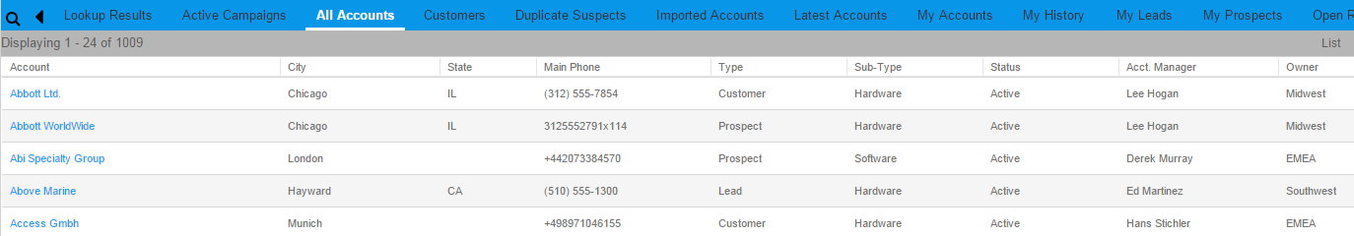

#### Customized Groups for the Accounts module

|  |  |
| --- | --- |
| Comments: | *Sample* |
| Group Name: | *House Accounts* |
| Conditions: | *Type = Customer* |
| Layout (Columns): | *Account, City, State, Main Phone, Type, Sub-Type, Status, Acct. Manager, Owner* |
| Sorting: | *Account Descending* |

DoD suggested Group layout:

|  |  |
| --- | --- |
| Comments: | *DoD Suggestion* |
| Group Name: | *House Accounts* |
| Conditions: | *Type = Customer* |
| Layout (Columns): | *Account, City, County, State, (Main Office Phone – remove if we need to save real estate), Type, (Sub-Type - Industry), Status, (Acct. Manager – remove if we need to save real-estate /by default will be the Department Director/Supervisor), Owner, Stage(s)* |
| Sorting: | *Account Descending* |

## Contacts

Contacts are persons who work for or are part of an organization. Contacts must be associated to a specific Account.

### Out of the box Contacts Configurations

The Contact form is where Contact records are profiled and where high-level information about the individual is available at a glance. This is the “Out of the Box” configuration:

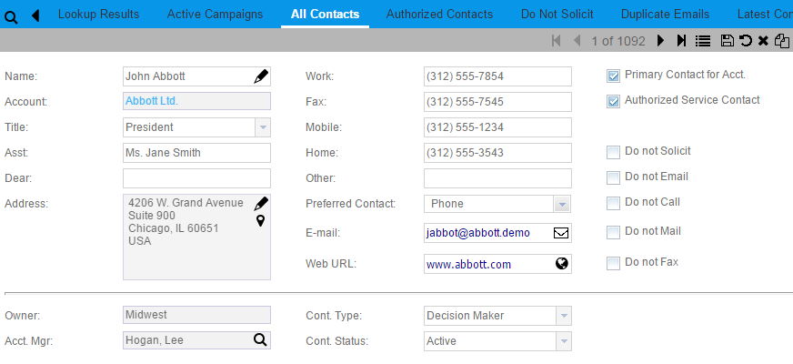

This is the “Out of the Box” Contact Detail form:

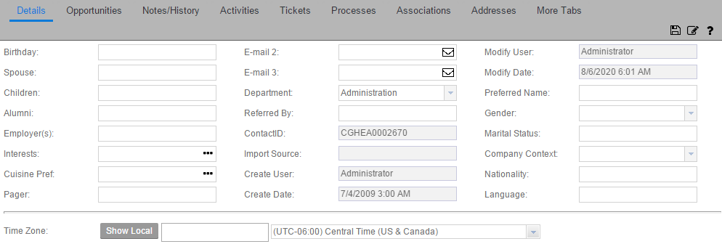

### Customized Contacts module

To accommodate ‘Anonymous’ callers, an account/contact such as HHS Anonymous will be established. Anonymous callers will have their tickets logged against this account/contact.

To accommodate ‘General Information’ callers, an account/contact such as HHS General Information Requests will be established. Un-named callers will have their tickets logged against this account/contact.

In the Contact Lookup for HHS, need Name, Alert Flag, SSN, DOB, Phone. HHS requested to remove Account because in their world, Account=Contact. But this is not true for DoD and they need to have Account on the lookup. See information in the Contact Groups chapter of this document.

Future: if when entering a new Account/Contact, the system will not allow the user to Save if Account name not equal Contact. OR The system will auto load the Account from the Contact. BUT ONLY IF the user is HHS. Does this apply to all HHS agencies?

If possible, on the Insert Account/Contact and Insert Account, default the ‘Look for Matching Records’ options to First Name and Last Name, not Email. Per Infor, this is not technically possible. They suggest that CC creates a feature request.

Field Definitions

|  |  |  |  |
| --- | --- | --- | --- |
| **Field Name** | **Field Type** | **Values** | **Comments** |
| Job Title | Text |  | ~~List provided by CD~~  ~~List provided by ED~~  HHS will not use this field, and it is OK for this field to be displayed.  1/19 DoD requested this field be made text only, not a pick list |
| Account Manager | Lookup |  | Relabel as Contact Manager |
| Type | Multiselect Pick list | Account Manager  Agency Director  Attorney  Banker  Billing  Champion  CEO  CFO  Client  Collections  Community Contact  Contractor  County Agency  County Council (CCE)  County Executive Office  Court Representative  Credential Provider  Customer  Customer / Participant  Debtor – 1  Debtor – 2  Debtor – 3  Decision Maker  Director’s Office  Economic Dev Dir.  Employee  Employer  External Agency  Family Member / Guardian  Federal/State/City Rep.  Financial Contact  Friend  Gatekeeper  Guarantor  Home Owner  Homeless Person  Investigation Unit  Jobs Reporting Contact  Legal Aid Society  Legal Representative  Media Rep/Reporter  Network Provider  Owner  Parent  Parent Company  Partner  Principal  Probation Officer  Project Manager  Prosecutor’s Office  Refugee/Alien  Resident  Sales  School System Rep.  Social Services Rep./Agency  State Hearing Unit  Training Provider  Other Agency Rep.  Other | ~~Relabel ‘DoD Contact Type’~~  List provided by CD  List provided by ED  ~~Originally not used by CFS, but now will be. Values provided by HHS have been incorporated here.~~  Values updated by DoD on 1/19  Revised 1/22/18:  Combined Picklist values both DoD & HHS  Same list as Ticket > Contact Type |
| ~~HHS Contact Identified As~~ |  |  | Removed 1/24 since the Type field contains both DoD and HHS entries |
| Authorized Service Contact |  |  | Hide ** |
| Address |  |  | Training note - required |
| EMail |  |  | Training note - required |
| Other City | text |  | New; under the Address block |
| County | Pick list |  | New; under new field Other City;  Same pick list as Account > County |
| Address popup > Description |  |  | Default to Home ** |
| Address popup > Address Type |  |  | Default to Home ** |
| Preferred Contact | Pick list | Call  Chat  County Website  CRM Portal  Email  In Person  Letter  Text | Relabel as Preferred Contact Method;  List provided by HHS; same picklist as Ticket > Preferred Method of Comm.  Training note - required |
| Status |  |  | No changes |
| Gender | Pick list | Retain existing values | Move up from the Detail tab |
| Contact Association Types |  | Account Manager  Agency Director  Attorney  Banker  Billing  Champion  CEO  CFO  Client  Collections  Community Contact  Contractor  County Agency  County Council (CCE)  County Executive Office  Court Representative  Credential Provider  Customer  Customer / Participant  Debtor – 1  Debtor – 2  Debtor – 3  Decision Maker  Director’s Office  Economic Dev Dir.  Employee  Employer  External Agency  Family Member / Guardian  Federal/State/City Rep.  Financial Contact  Friend  Gatekeeper  Guarantor  Home Owner  Homeless Person  Investigation Unit  Jobs Reporting Contact  Legal Aid Society  Legal Representative  Media Rep/Reporter  Network Provider  Owner  Parent  Parent Company  Partner  Principal  Probation Officer  Project Manager  Prosecutor’s Office  Refugee/Alien  Resident  Sales  School System Rep.  Social Services Rep./Agency  State Hearing Unit  Training Provider  Other Agency Rep.  Other | List provided by DoD  HHS will not use this function at time of Pilot  1/24 use same pick list as Contact Type |
| HHS Alert | checkbox |  | New. Must also be on the Contact lookup and list view; used to designate a Contact needing special handling; maintained manually |
| Contact > Ticket list view | Description |  | Replace with Subject from the ticket |
| Detail tab > Department | Pick list | Engineering  Human Resources  IT  Maintenance  QA  Safety  Transportation  Other | Replace OOTB values with these.  1/24 updated to be a simple pick list, NOT user entered pick list |
| Detail tab > SSN Last 4 |  |  | New, no security, 4 digit field; if needed will be manually entered by the WI All team because they have access to the full SSN on the duplicate Contact records > HHS Detail tab |
| Detail tab - Language |  |  | Multi select picklist, same as on HHS Detail tab |
| Detail tab – Language Other | text |  |  |
| **HHS Detail** |  |  | **New tab secured from access by all but HHS Role###** |
| HHS Detail tab |  |  | Add a SAVE icon on the header bar |
| HHS Detail - Alert | multiselect | |  | | --- | | ADA - Americans With Disabilities | | Domestic Violence Risk | | Gender Sensitivity **Special Training | | Hearing Impaired | | Interpreter Services Needed | | LEP - Limited English Proficiency | | Repeat Caller | | List provided by HHS |
| HHS Detail - DOB | date |  | Move from Contact Detail;  Training note - required |
| HHS Detail - SSN | 9 numeric |  | Move from Detail tab; Secure to only HHS All users; limited to 9 numeric total; Training note - required |
| HHS Detail - Spouse | text |  | Move from Contact Detail |
| HHS Detail - Children | text |  | Move from Contact Detail |
| HHS Detail - Nationality | text |  | Move from Contact Detail |
| HHS Detail - Language | Multi select picklist | |  |  |  |  |  |  |  |  |  |  |  |  |  |  |  |  |  |  |  |  |  |  |  |  |  |  |  |  |  |  |  |  |  |  | | --- | --- | --- | --- | --- | --- | --- | --- | --- | --- | --- | --- | --- | --- | --- | --- | --- | --- | --- | --- | --- | --- | --- | --- | --- | --- | --- | --- | --- | --- | --- | --- | --- | --- | | |  | | --- | | American Sign Language | | Albanian | | Amharic | | Arabic | | Armenian | | Bengali | | Cape Verdean Creole | | Chinese | | French / Francais | | German / Deutsch | | Greek | | Haitian Creole | | Hebrew | | Hindi | | Hmong | | Italian | | Japanese | | Khmer | | Korean | | Laotian | | Polish | | Portuguese | | Russian | | Serbo-Croation | | Somali | | Spanish | | Swahili | | Tagalog | | Thai | | Ukranian | | Urdu | | Vietnamese | | Other (Fill-In) | | | Duplicate from Contact Detail and make multi select  Paired with Other Language (Fill-In) – or make this list be user entered and do not have the paired field  HHS specifically asked for American Sign Language first even though its out of alpha order. |
| HHS Detail – Other Language (Fill-In) | text |  | Paired with Language |
| HHS Detail – Person ID | text |  | Person ID and Case Mgmt System are paired fields;  This pair of fields should be listed 6 separate times on the HHS Detail tab |
| HHS Detail – Case Mgmt System (does not require a field label) | Pick list | CCIDS (JFS)  HMIS (Homeless Services)  OH Benefits (OBWP/JFS)  OnBase Workview (OCSS)  PeerPlace (FCFC)  PeerPlace (DSAS)  SACWIS (CFS)  SETS (OCSS) | List provided by HHS;  Alpha order this list |
| HHS Detail – Contact ID |  |  | Replicate from Contact Detail, R/O |
| HHS Detail – Import Source |  |  | Replicate from Contact Detail, R/O |
| HHS Detail – Create User |  |  | Replicate from Contact Detail, R/O |
| HHS Detail – Create Date |  |  | Replicate from Contact Detail, R/O |
| HHS Detail – Modify User |  |  | Replicate from Contact Detail, R/O |
| HHS Detail – Modify Date |  |  | Replicate from Contact Detail, R/O |
| **SkillUp** |  |  | **New tab to designate credentials/trainings this contact possesses; grid view ###** |
|  |  |  |  |
| SkillUp > Category |  |  | Pull from Skills/Credentials entity |
| SkillUp > Skill Type |  |  | Pull from Skills/Credentials entity |
| SkillUp > Skill SubType | Lookup to Skills/Credentials |  | Pull from Skills/Credentials entity |
| SkillUp > Credential Type |  |  | Pull from Skills/Credentials entity |
| SkillUp > Credential SubType | Lookup to Skills/Credentials |  | Pull from Skills/Credentials entity |
| SkillUp > Date Obtained | date |  | Manual entry; for this Credential SubType for this contact |
|  |  |  |  |
|  |  |  |  |

### Contact Groups

#### Out of the box Group for the Contacts module

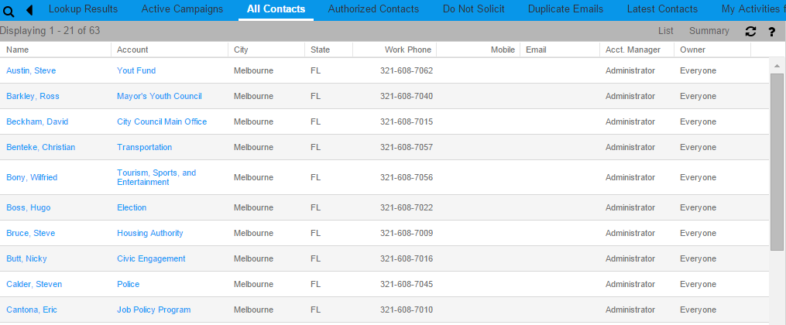

#### Customized Groups for the Contacts module

|  |  |
| --- | --- |
| Comments: | *Sample* |
| Group Name: | *Florida Contacts* |
| Conditions: | *State = FL* |
| Layout (Columns): | *Name, Account, City, State, Work Phone, Email, Acct. Manager, Owner* |
| Sorting: | *Name Descending* |

DoD suggested Group layout:

|  |  |
| --- | --- |
| Comments: | *DoD Suggestion* |
| Group Name: | *Florida Contacts* |
| Conditions: | *State = FL* |
| Layout (Columns): | *Name, Account, City, County, State, Work Phone, Mobile Phone, Email, (Acct. Manager – remove if we need to save real-estate /by default will be the Department Director/Supervisor),, Owner, Stage* |
| Sorting: | *Name Descending* |

Four HHS suggested Group layouts:

In the Contact Lookup for HHS, need Name, Alert Flag, SSN, DOB, Phone.

|  |  |
| --- | --- |
| Comments: | *HHS ALL Contacts* |
| Group Name: | *HHS ALL Contacts* |
| Conditions: | *HHS ALL = “Owner”* |
| Layout (Columns): | *Name, Alert Flag, DOB, SSN, Home Phone, Email, Acct. Manager* |
| Sorting: | *Name Descending* |

|  |  |
| --- | --- |
| Comments: | *JFS Contacts* |
| Group Name: | *JFS Contacts* |
| Conditions: | *JFS = “Owner”* |
| Layout (Columns): | *Name, Alert Flag, DOB, SSN, Home Phone, Email, Acct. Manager* |
| Sorting: | *Name Descending* |

|  |  |
| --- | --- |
| Comments: | *CFS Contacts* |
| Group Name: | *CFS Contacts* |
| Conditions: | *CFS = “Owner”* |
| Layout (Columns): | *Name, Alert Flag, DOB, SSN, Home Phone, Email, Acct. Manager* |
| Sorting: | *Name Descending* |

|  |  |
| --- | --- |
| Comments: | *Confidential Caseload Unit* |
| Group Name: | *Confidential Contacts* |
| Conditions: | *”Confidential Caseload” = “Owner”* |
| Layout (Columns): | *Name, Alert Flag, DOB, SSN, Home Phone, Email, Acct. Manager* |
| Sorting: | *Name Descending* |

## Opportunities

An opportunity in InforCRM represents a potential sale. This may be a new sale of product or services, a renewal of contracts, etc.

### Out of the box Contacts Configurations

The Opportunity Detail view is where Opportunity records are profiled and where high-level information about the potential sale is available at a glance. This is the “Out of the Box” configuration:

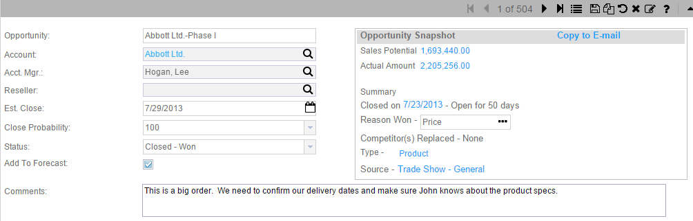

### Customized Opportunities module

#### Field Definitionions

|  |  |  |  |
| --- | --- | --- | --- |
| **Field Name** | **Field Type** | **Values** | **Comments** |
| Account Manager |  |  | Relabel as Opportunity Manager;  Edit is secured to Opportunity Manager Role |
| Reseller |  |  | Hide ** |
| Opportunity Type | Cascading pick list | ED  CD  WI | New; each value cascades to a separate SubType list ***** |
| Opportunity SubType | Pick list | * 4COM * Developer Loans * Downpayment Assistance * Fair Housing * HELP Loan * Heritage Home * Homeowner Counseling * LEAD Grant * Muni Demo * Muni CDBG Grant Agmt * Muni Supplemental * Rent Assistance * Store Fronts * Other | New; Type = CD |
| Opportunity SubType | Pick list | * Attraction * Real Estate * Retention * Growth/Expansion * Innovation/Entrepreneurship * Other | New; Type = ED  Values provided by Paul H 12/21 via phone call  Updated 1/17 by DoD |
| Opportunity SubType | Pick list | * SkillUp Foundational * SkillUp Technical * SkillUp Other | New; Type = WI  Updated 1/17 by DoD |
| Status |  | Open  Closed-Won  Closed-Lost  Do not Contact  ED Loan App in Process  Follow-up  Inactive  Interested  Lead  No Response  Not Interested  Portfol  Prospect  Referred to 3rd Party Lender | Closed-Won and Closed-Lost both allow the entry of a reason why |
| Opportunity # | text |  | New field in Opportunity Main screen;  Used by DoD for:  ED – Loan #  CD – Account #, Loan #  SUP – SkillUp # |
| Retirement Benefits Provided | checkbox |  | New field, manually entered |
| **DoD Programs** |  |  | **New tab with left side columns and right side columns ###** |
| **ED Programs** |  |  | **Left side header** |
| Referral Type | Cascading Picklist | Entrepreneur & Oppty  Technical Assistance | ***** |
| Referral SubType | Pick List | Accelerated Growth GOP  Capital Access Loan / NDC  Early Stage / Jumpstart  Grow Cuyahoga / NDC  Micro Loan / ECDI  Pre-Seed / Jumpstart  SBA-insured Bank Loan  Other | Entrepreneur & Oppty |
| Referral SubType | Pick List | NASA  MAGNET  Other | Technical Assistance |
| **CD Programs** |  |  | **Right side header** |
| Meets HUD Income Limits | Checkbox |  |  |
| Home 50 Yrs and Older | Checkbox |  |  |
| City | Lookup to address |  | Auto fill from Address City |
| Repair Type | Multi select Pick list | Additions to Structure  Air Conditioning  Carport  Caulking  Chimney  Decks  Defective Paint Sufaces  Disability - ADA Compliance  Double pane Windows  Downspouts  Drainage Issues  Driveways  Electrical System  Fencing  Finished Attics  Finished Basements  Fire Damage  Flooring  General Landscape  Gutters  Incipient Health Issues  Insect Infestation  Insulateed Exterior Doors  Insulation  Heating System  Hot Water System  Lead-based Paint  Lead Remediation  Patio  Plumbing fixtures  Public Water System  Roof  Safety Issues  Sewer System  Skylights  Stair Railings  Stuctural Damage  Termite Damage  Terraces  Treatment against termites  Tree Removal  Walks  Weatherstripping  Well  Other | List provided by DoD - Pending Ken Surratt confirmation |
| Repair Type Other | text |  | New. Paired with Repair Type |
| Senior Citizen | Checkbox |  |  |
| DOB | Date |  |  |
| Org Referred To | Pick list | Third Party Entity  Other | New field paired with Other |
| Org Referred To Other | text |  | New field paired with Org Referred To |
| Foreclosure | Checkbox |  |  |
| Short Sale | Checkbox |  |  |
| **Opportunity Contact** |  |  |  |
| Starting Wage | Text |  | New |
| In-Training Wage | Text |  | New |
| Post-Training Wage | Text |  | New |
| Role | Pick list | Attorney  Business Client  Candidate  Credential Provider  Decision Maker  Employee  Employer  Gatekeeper  Influencer  Supports Competitor  Trainee  Training Provider  User  Other | List provided by DoD SUP |
| Standing | Pick list | Hired  No Show  Not Hired  Not Qualified  Other | List provided by DoD SUP |
| Invoice Information |  |  | Group of 4 fields, repeated 10 times on the bottom left side of the screen, paired with Check Information |
| PO # | text |  |  |
| Invoice # | Text |  |  |
| Invoice Date | Date |  |  |
| Invoice Amount | Currency |  |  |
| Check Information |  |  | Group of 3 fields, repeated 10 times on the bottom right side of the screen, paired with Invoice Information |
| Check # | Text |  |  |
| Check Cut Date | Date |  |  |
| Check Amount | Currency |  |  |
| **Opportunity Site** |  |  | **New tab, grid view, allow selection of Site from the County Site entity ###**  **Secure from access by all but DoD Role** |
| Opportunity Site > Site/Building Name | Lookup to County Site entity |  | New |
| Opportunity Site > Contact Name | Text |  | New; system supplied |
| Opportunity Site > Contact Company | Text |  | New; system supplied |
| Opportunity Site > Comments | Text – 255 char |  | New; Specific to this Site on this Opportunity |
| **SkillUp** |  |  | **New tab to designate credentials/trainings this opportunity requires; grid view ### Secure from access by all but SUP Role** |
|  |  |  |  |
| SkillUp > Category |  |  | Pull from Skills/Credentials entity |
| SkillUp > Skill Type |  |  | Pull from Skills/Credentials entity |
| SkillUp > Skill SubType | Lookup to Skills/Credentials |  | Pull from Skills/Credentials entity |
| SkillUp > Credential Type |  |  | Pull from Skills/Credentials entity |
| SkillUp > Credential SubType | Lookup to Skills/Credentials |  | Pull from Skills/Credentials entity |
| SkillUp > Comments | text |  | Manual entry; for this Credential SubType for this Opportunity |
|  |  |  |  |

### Opportunity Groups

#### Out of the box Group for the Opportunities module

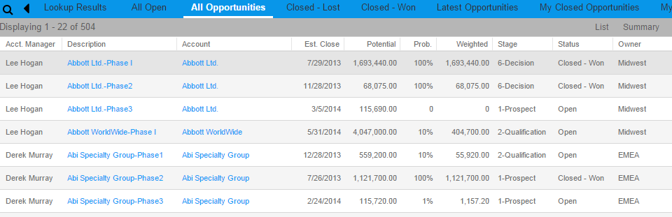

#### Customized Groups for the Opportunities module

|  |  |
| --- | --- |
| Comments: | *Sample* |
| Group Name: | *Top Opportunities* |
| Conditions: | *Probability = 100* |
| Layout (Columns): | *Account, Description, Est. Close, Potential, Stage, Acct. Manager, Owner* |
| Sorting: | *Account Descending* |

DoD SUP suggested Group layout:

|  |  |
| --- | --- |
| Comments: | *Sample* |
| Group Name: | *Top Opportunities* |
| Conditions: | *Probability = 100* |
| Layout (Columns): | *Account, Description, Est. Close, Potential, Probability, Stage, (Acct. Manager - remove if we need to save real-estate /by default will be the Department Director/Supervisor), Owner* |
| Sorting: | *Account Descending* |

### Sales Processes

Many different Sales Processes can be defined in the CRM system, and subsequently selected for any given opportunity. The Step Name is systematically limited to 64 characters, additional characters will be truncated.

Some Sales Process Actions will automatically trigger the Activity window to appear to facilitate successful completion of the Step. For example, if a Step is established with an Action = Phone Call or Meeting or ToDo, when the user clicks on the Step, a Create Activity window will pop up so the user can immediately take action.

Additionally, various fields can be defaulted into the Activity popup, based upon the setup of the Sales Process Step.

These are the available Action values:

* None
* Basic Script
* Contract Process
* Literature Request
* Mail Merge
* Meeting
* Phone Call
* To-Do

**Sales Process Name: Discovery**

|  |  |  |  |
| --- | --- | --- | --- |
| **Stage** | **Stage Name** | **Probability** | **Days to close** |
| 1 | Expert Advice | 50% |  |
| 2 | SkillUp | 50% |  |
| 3 | Other Business Needs | 0% |  |

|  |  |  |  |  |
| --- | --- | --- | --- | --- |
| **Stage** | **Step** | **Action** | **Required** | **Order** |
| Expert Advice | Complete Workforce Needs Questionnaire | Meeting/Phone | Yes | 1 |
| SkillUp | SkillUp Technical | Meeting/Phone | No | 2 |
| SkillUp | SkillUp Foundational | Meeting/Phone | No | 3 |
| Other Business Needs | Capital | To Do | No | 4 |
| Other Business Needs | Talent | To Do | No | 5 |
| Other Business Needs | General Business Needs | To Do | No | 6 |
| Other Business Needs | Real Estate Sites | To Do | No | 7 |

**Sales Process Name: SkillUp**

|  |  |  |  |
| --- | --- | --- | --- |
| **Stage** | **Stage Name** | **Probability** | **Days to close** |
| 1 | Commitment Letter | 10% |  |
| 2 | Scope Of Work | 20% |  |
| 3 | Talent Needed | 25% |  |
| 4 | Custom Roadmap | 50% |  |
| 5 | No Go - Training Process Management | 100% |  |
| 6 | No Go - Talent | 50% |  |
| 7 | Go - Talent | 65% |  |
| 8 | Go - Training Process Management - 1 | 75% |  |
| 9 | Go - Training Process Management - 2 | 85% |  |
| 10 | Go - Training Process Management - 3 | 90% |  |
| 11 | Go - Training Process Management - 4 | 95% |  |
| 12 | Go - Training Process Management - 5 | 100% |  |

|  |  |  |  |  |
| --- | --- | --- | --- | --- |
| **Stage** | **Step** | **Action** | **Required** | **Order** |
| Commitment Letter | Receive Signed Commitment Letter | To Do | Yes | 1 |
| Commitment Letter | Schedule First of 8 quartely meetings with Employer account - or CRM calendar to followup for 8 meetings over a 2 year (24 Month) period | To Do | Yes | 2 |
| Commitment Letter | Meeting 1 of 8 - Complete | Meeting/Phone | No | 3 |
| Commitment Letter | Meeting 2 of 8 - Complete | Meeting/Phone | No | 4 |
| Commitment Letter | Meeting 3 of 8 - Complete | Meeting/Phone | No | 5 |
| Commitment Letter | Meeting 4 of 8 - Complete | Meeting/Phone | No | 6 |
| Commitment Letter | Meeting 5 of 8 - Complete | Meeting/Phone | No | 7 |
| Commitment Letter | Meeting 6 of 8 - Complete | Meeting/Phone | No | 8 |
| Commitment Letter | Meeting 7 of 8 - Complete | Meeting/Phone | No | 9 |
| Commitment Letter | Meeting 8 of 8 - Complete | Meeting/Phone | No | 10 |
| Scope Of Work | Draft Scope Of Work | To Do | Yes | 1 |
| Scope Of Work | Get Job Description if applicable | To Do | No | 2 |
| Scope Of Work | Finalize Scope Of Work | To Do | Yes | 3 |
| Scope Of Work | Review with SkillUp Workforce Supervisor | To Do | No | 4 |
| Scope Of Work | Review Scope of Work with Account Contact - Revise as needed | Meeting/Phone/Email | Yes | 5 |
| Scope Of Work | Receive Signed Scope of Work | To Do | Yes | 6 |
| Talent Needed | Talent Needed |  | No | 1 |
| Talent Needed | Notify 3rd Party Talent Providers of Talent Needs | Meeting/Phone/Email | No | 2 |
| Talent Needed | 3rd Party Talent Providers to Outreach to Their Clients/Candidates To Notify About Opportunity | To Do | No | 3 |
| Custom Roadmap | SkillUp Foundational Skills Only - No Custom Research & Roadmap Required |  | No | 1 |
| Custom Roadmap | Begin Custom Roadmap Process | To Do | No | 2 |
| Custom Roadmap | Workforce Analyst Reviews All Documents For Completeness - Revise as Needed | To Do | No | 3 |
| Custom Roadmap | Create project based job description (if needed) | Meeting/Phone/Email | No | 4 |
| Custom Roadmap | Research Training Provider Options | To Do | No | 5 |
| Custom Roadmap | Research Credential Provider Options | To Do | No | 6 |
| Custom Roadmap | Populate Roadmap Template Based on Job Duties and Research Completed. Format Document and review for accuracy and completeness | To Do | No | 7 |
| Custom Roadmap | Review with SkillUp Workforce Supervisor and revise as needed | Meeting/Phone | No | 8 |
| Custom Roadmap | Review Custom Roadmap with Account Contact - Revise as needed | Meeting | Yes | 9 |
| Custom Roadmap | Finalize Roadmap | To Do | Yes | 10 |
| Custom Roadmap | Attach Skills/Credentials To Opportunity | To Do | Yes | 11 |
| No Go - Training Process Management | Receive Confirmation from Account - No Go For Training Process Management | Meeting/Phone/Email | No | 1 |
| No Go - Talent | Receive Confirmation from Account - No Go For Talent | Meeting/Phone/Email | No | 1 |
| Go - Talent | Receive Confirmation from Account - Go For Talent | To Do | No | 1 |
| Go - Talent | 3rd Party Talent Providers email resumes to JFS to consider for Opportunity | Meeting/Phone/Email | No | 2 |
| Go - Talent | JFS creates an account and contact for 3rd party talent provider (if needed) | To Do | No | 3 |
| Go - Talent | JFS creates a contact for each 3rd party candidate referred (if needed) an assign role as "candidate". Associate Skills/Credentials To contact. Associate Candidate to opportunity. Attach PAN Report to contact. | To Do | No | 4 |
| Go - Talent | Talent Advisor send candidate resume and PAN talent report to employer account | Meeting/Phone/Email | No | 5 |
| Go - Talent | Talent Advisor receive confirmation from employer account of intent to hire & train using SkillUp | Meeting/Phone/Email | No | 6 |
| Go - Talent | Update Opportunity contact "standing"/"Status" | To Do | No | 7 |
| Go - Talent | JFS to create candidate referral reports For County Leadership & 3rd Parties | To Do | No | 8 |
| Go - Talent | JFS to update 3rd party talent providers about candidate status | Meeting/Phone/Email | No | 9 |
| Go - Training Process Management - 1 | Receive Confirmation from Account - Go For Training Process Management | To Do | Yes | 1 |
| Go - Training Process Management - 1 | Employer account contact – selects training and credentialing provider and details. | To Do | Yes | 2 |
| Go - Training Process Management - 1 | Talent Advisor coordinates training with training provider | Meeting/Phone/Email | No | 3 |
| Go - Training Process Management - 1 | Create a Draft Training Plan - including sequencing the training | To Do | No | 4 |
| Go - Training Process Management - 1 | Review draft training plan with SkillUp Workforce Supervisor | Meeting/Phone/Email | No | 5 |
| Go - Training Process Management - 1 | Review Draft Training Plan with Employer Account Contact - Revise as needed | Meeting/Phone/Email | No | 6 |
| Go - Training Process Management - 1 | Create Final Training Plan & Send to Employer Account Contacts & Share with Trainees | Meeting/Email | No | 7 |
| Go - Training Process Management - 2 | Talent Advisor completes and finalizes cost worksheet | To Do | No | 1 |
| Go - Training Process Management - 2 | Talent Advisor completes and emails employer requirements packet to Employer Account Contact | To Do | No | 2 |
| Go - Training Process Management - 2 | Talent Advisor creates opportunity contact entity for each employee being trained. Assign relevanr role. | To Do | No | 3 |
| Go - Training Process Management - 2 | Employer register in buyspeed | To Do | No | 4 |
| Go - Training Process Management - 2 | Employer sends employee disclosure form to JFS | To Do | No | 5 |
| Go - Training Process Management - 2 | Employer signs employer requirements & sends signature page to talent advisor | To Do | No | 6 |
| Go - Training Process Management - 2 | Employer sends W9 & certificates of insurance (Workers Compensation, Auto, Umbrella, etc.) to Talent Advisor | To Do | No | 7 |
| Go - Training Process Management - 2 | Talent Advisor works with SkillUp Workforce Supervisor to perform legal review on Employer documents - Revise and receive additional documentation as directed by County law department | To Do | No | 8 |
| Go - Training Process Management - 2 | County Law Department Approves Employer | To Do | No | 9 |
| Go - Training Process Management - 2 | Talent Advisor works with SkillUp Workforce Supervisor & HHS Fiscal to have reimbursement authorized by County Board of Control | To Do | No | 10 |
| Go - Training Process Management - 2 | County Board of Control Approves training reimbursement | To Do | No | 11 |
| Go - Training Process Management - 3 | Coordinate with all stakeholders - Training and credentialing provider, employer leadership and supervisors and trainees & JFS/3rd Party providers as applicable | Meeting/Phone/Email | No | 1 |
| Go - Training Process Management - 3 | Training begins | To Do | No | 2 |
| Go - Training Process Management - 3 | Schedule 4 Coaching sessions for each trainee | To Do | No | 3 |
| Go - Training Process Management - 3 | Trainee completes PAN assessment. Attach PAN Report to contact entity. | To Do | No | 4 |
| Go - Training Process Management - 3 | Coaching Session 1 - Complete | Meeting/Phone | No | 5 |
| Go - Training Process Management - 3 | Coaching Session 2 - Complete | Meeting/Phone | No | 6 |
| Go - Training Process Management - 3 | Coaching Session 3 - Complete | Meeting/Phone | No | 7 |
| Go - Training Process Management - 3 | Coaching Session 4 - Complete | Meeting/Phone | No | 8 |
| Go - Training Process Management - 3 | Employer Account submits completed progress report - Stage 1 | Email | No | 9 |
| Go - Training Process Management - 3 | Employer Account submits completed progress report - Stage 2 | Email | No | 10 |
| Go - Training Process Management - 3 | Employer Account submits completed progress report - Stage 3 | Email | No | 11 |
| Go - Training Process Management - 3 | Employer Account submits completed progress report - Stage 4 | Email | No | 12 |
| Go - Training Process Management - 4 | Training was successfully completed | Email | No | 1 |
| Go - Training Process Management - 4 | Send Employer Account a user experience survey | To Do | No | 2 |
| Go - Training Process Management - 5 | Employer requests reimbusement for approved training related expenses - Stage 1. Employer provides the following to the Talent Advisor: Invoice, Payroll Record/Paystub, Paid Invoices/Receipts, and any other relevant documentation | To Do | No | 1 |
| Go - Training Process Management - 5 | Employer requests reimbusement for approved training related expenses - Stage 2. Employer provides the following to the Talent Advisor: Invoice, Payroll Record/Paystub, Paid Invoices/Receipts, and any other relevant documentation | To Do | No | 2 |
| Go - Training Process Management - 5 | Employer requests reimbusement for approved training related expenses - Stage 3. Employer provides the following to the Talent Advisor: Invoice, Payroll Record/Paystub, Paid Invoices/Receipts, and any other relevant documentation | To Do | No | 3 |
| Go - Training Process Management - 5 | Employer requests reimbusement for approved training related expenses - Stage 4. Employer provides the following to the Talent Advisor: Invoice, Payroll Record/Paystub, Paid Invoices/Receipts, and any other relevant documentation | To Do | No | 4 |
| Go - Training Process Management - 5 | SkillUp Workforce Supervisor reviews reimbursement request and completes invoice checklist for completeness and accuracy. Request additional documentation from employers as necessary. - Stage 1. | To Do | No | 5 |
| Go - Training Process Management - 5 | SkillUp Workforce Supervisor reviews reimbursement request and completes invoice checklist for completeness and accuracy. Request additional documentation from employers as necessary. - Stage 2. | To Do | No | 6 |
| Go - Training Process Management - 5 | SkillUp Workforce Supervisor reviews reimbursement request and completes invoice checklist for completeness and accuracy. Request additional documentation from employers as necessary. - Stage 3. | To Do | No | 7 |
| Go - Training Process Management - 5 | SkillUp Workforce Supervisor reviews reimbursement request and completes invoice checklist for completeness and accuracy. Request additional documentation from employers as necessary. - Stage 4. | To Do | No | 8 |
| Go - Training Process Management - 5 | SkillUp Workforce Supervisor is notified by HHS Fiscal that check has been cut--Includes Date, Check number and Amount - Stage 1. | To Do | No | 9 |
| Go - Training Process Management - 5 | SkillUp Workforce Supervisor is notified by HHS Fiscal that check has been cut--Includes Date, Check number and Amount - Stage 2. | To Do | No | 10 |
| Go - Training Process Management - 5 | SkillUp Workforce Supervisor is notified by HHS Fiscal that check has been cut--Includes Date, Check number and Amount - Stage 3. | To Do | No | 11 |
| Go - Training Process Management - 5 | SkillUp Workforce Supervisor is notified by HHS Fiscal that check has been cut--Includes Date, Check number and Amount - Stage 4. | To Do | No | 12 |

**Sales Process Name: C. D. 4COM – Out of Scope** (Documented for System Administrator to implement)

|  |  |  |  |
| --- | --- | --- | --- |
| Stage | Stage Name | Probability | Days to close |
| 1 | Application |  |  |
| 2 | Eligibility |  |  |
| 3 | Management Review |  |  |

|  |  |  |  |  |
| --- | --- | --- | --- | --- |
| Stage | Step | Action | Required | Order |
| Application | Application | Email | No | 1 |
| Application | * Copy of your most recent gas, electric, water and sewer bills. | Email | No | 2 |
| Application | * Copy of the declaration page that indicates the amount of homeowner’s insurance, date of coverage and amount of premium. | Email | No | 3 |
| Application | * Copy of your most recent six (6) pay stubs. | Email | No | 4 |
| Application | * Copy of recent pension pay statement. | Email | No | 5 |
| Application | * Copy of most recent social security/disability income award letter | Email | No | 6 |
| Application | * Copy of SSI benefit for minors. | Email | No | 7 |
| Application | * Signature on the attached Request for verification of Employment for each employer for all members of the household 18-years of age and older. | Email | No | 8 |
| Application | * If you have children 18-years of age and older who attend school, please submit a copy of their school registration. | Email | No | 9 |
| Application | * Copy of your most recent mortgage statement that reflects the mortgage balance, your payment and escrow information. | Email | No | 10 |
| Application | * Copy of court order for award of monthly child support payments. You will also need to contact Child Support Enforcement Agency at (216) 263.4500 to obtain a printout of you child support payment history for the past six months. | Email | No | 11 |
| Application | * Copy of your last two quarterly statements for any stocks, bonds, money market, IRA, 401K, Keogh accounts or any similar types of interest baring accounts. | Email | No | 12 |
| Application | * Copies of your complete (all pages) checking and savings account statements for the past six months. | Email | No | 13 |
| Application | * If you have self-employment income or rental income, a signed copy of your current federal Income Tax Return with the appropriate (Schedules C and/or E) to verify your income from slef employment and/or rental property. | Email | No | 14 |
| Application | * Copy of statement from your insurance company that reflect any cash value in your life policies before death (Whole Life and/or Universal Life policies). | Email | No | 15 |
| Eligibility | * Input data into elgibility template | To-Do | No | 1 |
| Eligibility | * Prepare recommendation for management | To-Do | No | 2 |
| Management Review | * Manager reviews eligibility decison | To-Do | Yes | 3 |

## Custom County Sites Entity

A new custom entity, County Sites, will be used to track vacant land and vacant buildings within the county.

A given Site may be associated to any number of Opportunities. Therefore, one custom tab will show the Opportunities that the Site is linked to.

An initial load of data will be provided from the ZP_Report file.

Access to the County Sites entity will be restricted to the DoD Role.

### County Sites main view

This is a sample mock up of what the County Sites main screen might look like.

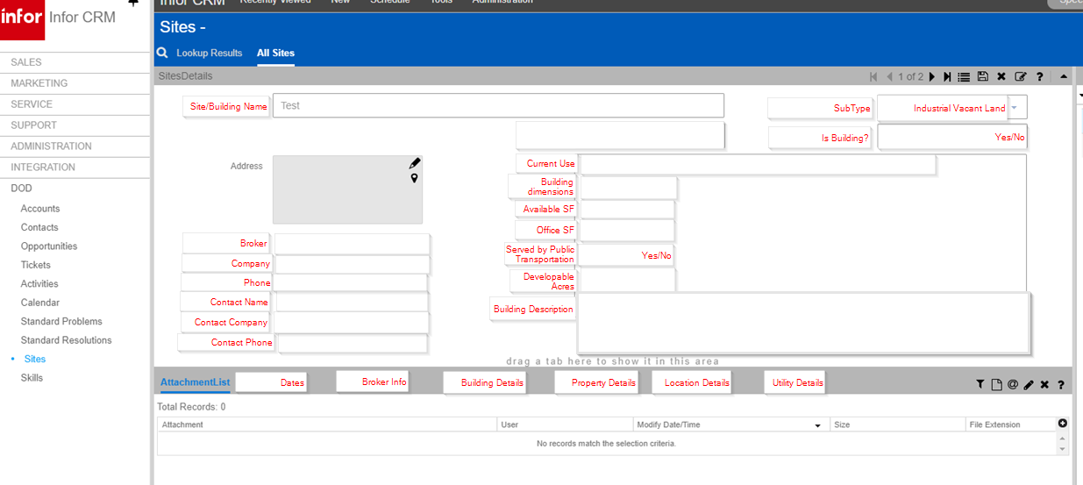

#### Field Definitionions

|  |  |  |  |
| --- | --- | --- | --- |
| **Field Name** | **Field Type** | **Values** | **Comments** |
| Site/Building Name | Text |  | From ZP_Report or manual entry |
| SubType | Text |  | From ZP_Report or manual entry |
| Is Building? | Checkbox |  | From ZP_Report or manual entry; All data from the ZP_Report file will load, however new manual entries must select |
| Address | Address |  | From ZP_Report or manual entry |
| City | Pick list | List of Municipalities from HHS | All data from the ZP_Report file will load, however new manual entries must select from the pick list |
| Broker | Text |  | From ZP_Report or manual entry |
| Broker Lookup | Lookup to Contacts |  | Manual entry |
| Company | Text |  | From ZP_Report or manual entry |
| Phone | Phone |  | From ZP_Report or manual entry |
| Contact Name | Text |  | From ZP_Report or manual entry |
| Contact Lookup | Lookup to Contacts |  | Manual entry |
| Contact Company | Text |  | From ZP_Report or manual entry |
| Contact Phone | phone |  | From ZP_Report or manual entry |
| Current Use | text |  | From ZP_Report or manual entry |
| Building Dimensions | text |  | From ZP_Report or manual entry |
| Available SF | text |  | From ZP_Report or manual entry |
| Office SF | text |  | From ZP_Report or manual entry |
| Served by Public Transportation | Checkbox |  | From ZP_Report or manual entry; All data from the ZP_Report file will load, however new manual entries must select |
| Developable Acres | text |  | From ZP_Report or manual entry |
| Building Description | text |  | From ZP_Report or manual entry |
| Comments | text |  | From ZP_Report or manual entry |
| **Site Opportunities** | tab |  | **Custom tab** |
| Site Opportunities > Opportunity Name | Lookup to opportunities |  | Auto link from any opportunity that has this Site linked as an Opportunity Site |
| Site Opportunities > Account Name |  |  | System supplied via lookup |
| Site Opportunities > Opportunity SubType |  |  | System supplied via lookup |
| Site Opportunities > Comments |  |  | System supplied via lookup |
|  |  |  |  |
|  |  |  |  |

## Custom Skills/Credentials Entity

A new custom entity, Skills/Credentials, will be used to maintain a master list of credentials to facilitate the County business processes for the SkillUp Services. These credentials can be selected on a separate Skills/Credentials tab at the account level for training providers, at the contact level to show what credentials a contact possesses, and also at the opportunity level to identify what credentials are needed to satisfy the opportunity. Maintaining the master list in a separate entity will ensure consistency across accounts, contacts and opportunities.

The Skills/Credentials entity is restricted to the Credential Entity Role.

First 6 fields are required, not Comments.

Hover text on Skill SubType and Test SubType = Type “None” if no value exists.

### Credentials main view

This is a sample mock up of what the Skills/Credentials main screen might look like.

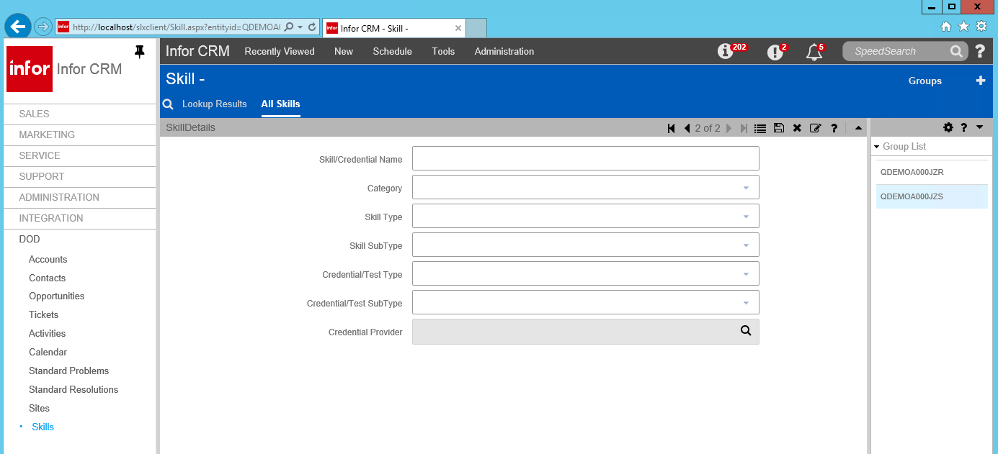

#### Field Definitionions

|  |  |  |  |
| --- | --- | --- | --- |
| **Field Name** | **Field Type** | **Values** | **Comments** |
|  |  |  |  |
| Category | Text |  |  |
| Skill Type | Text |  |  |
| Skill SubType | Text |  |  |
| Credential/Test Type | Text |  |  |
| Credential/Test SubType | Text |  |  |
| Credential Provider | Account lookup |  |  |
| Comments | text |  |  |
| Contact tab > Contact Name |  |  | Auto link from any Contact that has this Skill linked as an SUP Skill |
| Account tab > Account Name |  |  | Auto link from any Account that has this Skill linked as an SUP Skill |
| Opportunity tab > Opportunity Name |  |  | Auto link from any Opportunity that has this Skill linked as an SUP Skill |
| Opportunity tab > Opportunity SubType |  |  | System supplied |
| Opportunity tab > Opportunity Status |  |  | System supplied |
|  |  |  |  |

## Activities

TAI will modify Pick Lists related to the activities functionality if such changes are required by the customer. Changes to the the forms and fields related to Activities is out of scope.

These are values you have provided for the activity pick lists:

|  |  |  |  |
| --- | --- | --- | --- |
| **Phone Call Category** | **Phone Call Regarding** | **Phone Call Result** | **To Do Category** |
| Conference | Follow up on Ticket | Unsuccessful | Lead Processing |
| Installation | Return voice mail message | Finalized | Info Requested |
| Internal | Confirm Literature Received | In-Process | Fax Response |
| Leads | Confirm Meeting | Left V-message | Conference |
| Onsite Service | Follow-up | E-mail Sent | Training |
| Other Visit | Qualify for needs | Referred me | Onsite Service |
| Training | Discuss Opportunities | Call Back | Other Visit |
|  | Schedule a Meeting | Complete |  |
| **Meeting Category** |  |  | **To Do Regarding** |
| Strategic Relationship | **Meeting Regarding** | **Meeting Result** | Send e-mail message |
| Project Implementation | Review Ticket | Cancelled | Send literature |
| Training | Dinner meeting | Completed | Send proposal |
| Onsite Service | Breakfast meeting |  | Send letter |
| Other Visit | Lunch meeting | **To Do Result** | Send fax |
|  | Training | Referred Me |  |
|  | Demonstration | Delayed |  |
|  | Presentation | Call Back |  |
|  | Review requirments | Complete |  |
|  | Review proposal |  |  |
|  | Discuss Opportunities |  |  |
|  |  |  |  |
|  |  |  |  |

## Tickets

Tickets refer to issues that need to be captured and managed in CRM. Tickets have associations to Accounts, Contacts, and Activities as well as Standard Problems and Standard Resolutions

### Out of the box Ticket configurations

The Ticket form is where Ticket records are profiled and where high-level information about the Ticket is available at a glance. This is the “Out of the Box” configuration:

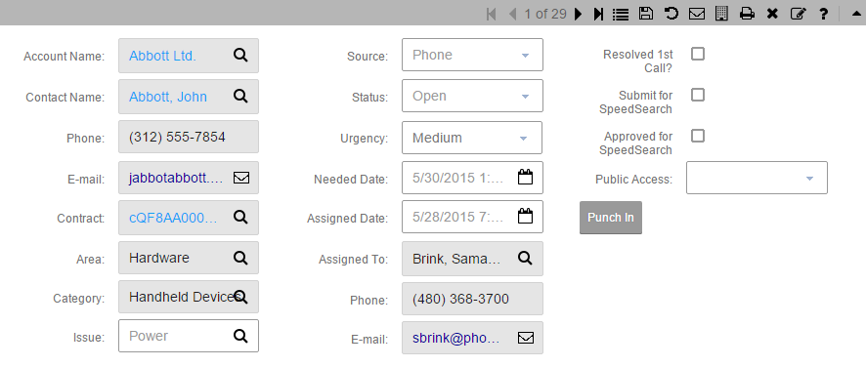

This is the “Out of the Box” Ticket Detail form:

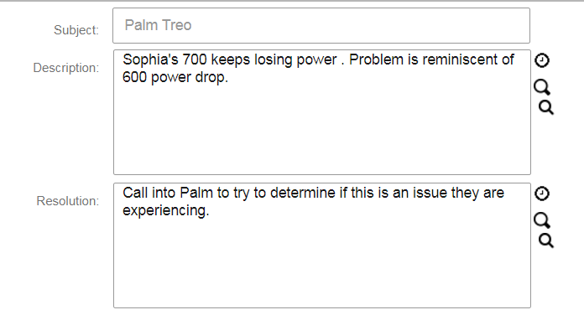

### Area Category Issue

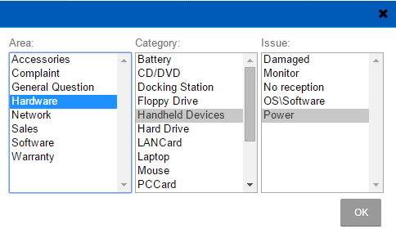

Area/Category/Issue is a cascading picklist. By selecting an Area the user will see a filtered list of possible Categories, and by selecting a Category the user will see a filtered list of possible Issues. Cuyahoga County has chosen to use Area to reflect a county agency.

|  |  |  |  |
| --- | --- | --- | --- |
| **Area** | **Category** | **Issue** | **Comments** |
| CD | Compliment |  | No values for Issue |
| CD | Funding Status | Demolition  Funding  Muni Grant  RFP Award  Storefront  Supplemental Grant  Other |  |
| CD | Home Owner |  | No values for Issue |
| CD | Housing | Application Status  Downpmt Assistance  Foreclosure  Home Repairs  Loan Status  Rent Assistance |  |
| CD | Taxes |  | No values for Issue |
| CD | Other |  | No values for Issue |
| ED | Compliment |  | No values for Issue |
| ED | Business Lead | Attraction  Expansion  Funding  New  Real Estate  Retention  Other |  |
| ED | Loan Status | Application Status  Disbursement  Payment  Reimbursement  Other |  |
| WI/SkillUp | Compliment |  | No values for Issue |
| WI/SkillUp | Employment Opportunities | Full Time  Part Time  Temporary | No values for Issue |
| WI/SkillUp | Workforce Skills Trng | Existing Employees  New Hires | No values for Issue |
| WI/SkillUp | Invoice Status | Received  In Progress  Paid | No values for Issue |
| WI/SkillUp | Other |  | No values for Issue |
| CFS, JFS | |  | | --- | | Administrative Review / Hearing Required | | Abuse / Neglect Reporting | | Appeal | |  | |  | |  | | Application Status | | Case / Address Change or Update | | Complaint | | Compliance | | Compliment | | Conciliation Request | |  | | Death Reporting | | Disaster Relief | | Domestic Violence Reporting | | Elder Abuse | | Formal Complaint | | General Information Request | | "How To" Assistance | | Interpreter Service Request | | Legal Aid Request | | New Worker Requested | | Payment / Cash / Check Status | | Public Records Request | | Re-Application / Intake Inquiry | | Records Request | |  | |  | | Referral / Staff Assist Request | | Release of Information Notice | | Sanction Inquiry | | Schedule / Reschedule Appt or Hearing | | Security or County Facilities Concern | | Sexual Abuse Reporting | | Theft Reporting | | Transportation Assistance | | Verification Assistance | | "Other" (Add description in notes) | |  | No values for Issue |
| CFS, JFS | Complaint  Formal Complaint | |  | | --- | | Attitude / Lack of Professionalism | | Contact Info. Incorrect / Unavailable | | Civil Rights Infraction - Alleged or Reported | | Dispute - Decision / Policy | | Dispute - Result / Negative Action | | Excessive Wait for Benefits | | Excessive Wait for Staff/Worker | | Excessive Wait at Servicing Location (15 mins or More) | | Excessive Wait at Servicing Location (30 mins or More) | | Excessive Wait at Servicing Location (1 hour or More) | | Inadequate Information | | Lack of Access - Call Not Returned | | Lack of Access - No Re-Application Interview Call | | Lack of Access - Voicemail Full / Continuous Ring | | Lack of Communication | | Lack of Follow-Up | | Late Communication | | Lost or Misplaced Documentation - Not in "System" | | Poor or Inadequate Service | | Processing Error | | Provider Complaint | | Referred to Wrong Point of Service | | Other (Fill-In) | |  |
| CFS | Compliment | |  | | --- | | Communication Excellence | | Explained Process & Next Steps Very Well | | Follow Through Excellence | | Knowledgeable Expert | | Listened Well & Allowed Time for Questions | | Polite Manner | | Prompt / Timely Assistance | |  |
| OCSS  FCFC  OHS  IIC  DSAS Re-Entry |  | Each agency will be listed in Area in case the ticket pertains to them, however we do not have their selections for Category and Issue at this time |  |
|  |  |  |  |

### Customized Ticket module

A future enhancement has been identified by HHS for the Ticket Detail tab > Referred to Internal County Agency: on screen user notification to ensure the “owner” and “Account Manager” fields at the Account level are updated accordingly.

#### Field Definitionions

|  |  |  |  |
| --- | --- | --- | --- |
| **Field Name** | **Field Type** | **Values** | **Comments** |
| Account Name |  |  | No changes |
| Contact Name |  |  | No changes |
| Contact Type | Pick List | Account Manager  Agency Director  Attorney  Banker  Billing  Champion  CEO  CFO  Client  Collections  Community Contact  Contractor  County Agency  County Council (CCE)  County Executive Office  Court Representative  Credential Provider  Customer  Customer / Participant  Debtor – 1  Debtor – 2  Debtor – 3  Decision Maker  Director’s Office  Economic Dev Dir.  Employee  Employer  External Agency  Family Member / Guardian  Federal/State/City Rep.  Financial Contact  Friend  Gatekeeper  Guarantor  Home Owner  Homeless Person  Investigation Unit  Jobs Reporting Contact  Legal Aid Society  Legal Representative  Media Rep/Reporter  Network Provider  Owner  Parent  Parent Company  Partner  Principal  Probation Officer  Project Manager  Prosecutor’s Office  Refugee/Alien  Resident  Sales  School System Rep.  Social Services Rep./Agency  State Hearing Unit  Training Provider  Other Agency Rep.  Other | New; placement above Phone field;  Values provided by HHS and DoD combined;  Same list as Contact > Contact Type |
| ~~HHS Compliment Type~~ |  |  | 1/24 Compliment was placed back into A/C/I |
| HHS Program/Dept. | Multi select Pick list | |  | | --- | | Adoption Assistance | | Aid to Dependent Children (ADC) | | Affordable Care Act (ACA) | | Child Care Assistance | |  | | Disability Assistance Program | | Emergency Funds / Cash Assistance | | E-Processing | | Grand Parent / Caregiver Initiative | | Fatherhood Initiative | | Financial Aid Assistance | | Healthy Start | | Homeless Services | | Housing Assistance | |  | | KIDS Hotline - 696-KIDS | | Medical | | Medicaid (SMBC) | | Negotiable Items | | OWF - Ohio Works First / ADC Cash (JET) | | PRC Program | | Short-Term Transitional Assistance (JET) | | SNAP = Food Assistance | | SNAP to Skills = Job Training | | TANF - Temporary Aid to Needy Families (JET) | | Transportation Allowance | | Unemployment Assistance | | Utility Assistance (HEAP) | | WORC - Workforce Opportunity Resource Ctr. | | Work Participation Programs | |  | | Other Program / Dept | | New, Values provided by HHS |
| NFSC Call Pertains to | Pick list | Old Brooklyn  Quincy Place  Southgate-JEH  Virgil Brown | New; 4 entries on the NFSC Location picklist from Deb 12/22 |
| Inbound Referral | Pick list | |  | | --- | | Community Contact | | County Council (CCE) | | County Executive Office | | Federal/State/City Rep | | Prosecutor's Office | | Social Services Rep / Agency | | Other Agency Rep | | Other | | New; Values provided by HHS;  To allow tracking of inbound issues from other agencies external to the county |
| Inbound Referral Email | Email |  | New; Paired with Inbound Referral |
| Source | Pick list | Chat  Conference  Email – Inbound  Email - Outbound  Fax  Mail  Marketing/Advertising  Networking  Phone – Inbound  Phone - Outbound  Presentation  Referral  Social Media  Walk In  Web Site  Other | Same pick list as Accounts > Lead Source  HHS will have to train staffers to select the appropriate items in Green. |
| Source Detail | Text |  | New field on Ticket Main screen; Paired with Source; Manually entered to provide additional information |
| Preferred Contact Method | Pick list | Call  Chat  County Website  CRM Portal  Email  In Person  Letter  Text | New; Same pick list as Contact > Preferred Contact Method;  Position under Source Detail |
| Status | Pick list |  | No changes identified;  Position under Preferred Contact Method |
| Urgency | Pick list | Urgent  High  Medium  Low | Replace with these in this order with Urgent on top;  No default  Position under Status |
| Needed Date | date |  | Relabel Due Date;  Position under Urgency |
| A/C/I |  |  | Make these 3 fields long enough so the user can read the entire entry in each box, they will take up 2 columns on the screen |
| Assigned To | Lookup to user |  | Relabel as Ticket Manager;  Move to center directly under A/C/I |
| External Assigned To (FN,LN) | Text |  | New; Move to center directly under Ticket Manager (fka Assigned To) |
| Assigned to Title | User entered Pick list | Caseworker  Supervisor  Manager  Sr. Manager  Contact Center Mgr  Other (Fill-In) | New; Move to center directly under External Assigned To; User entered picklist – they can type another title if they need one.  PLEASE RETAIN THE ORDER LISTED HERE |
| Phone | Phone |  | Relabel as Assigned To Phone;  Move to center directly under Assigned To Title |
| Email | Email |  | Relabel as Assigned To Email;  Move to center directly under Assigned To Phone |
| Assigned Date |  |  | Position under Assigned To Email |
| Escalated To | Text |  | New; position on right side of screen across from Ticket Manager |
| Escalated to Title | Text |  | New; position on right side of screen across from Assigned To Title |
| Escalated to Phone | Phone |  | New; position on right side of screen across from Assigned To Phone |
| Escalated to email | Email |  | New; position on right side of screen across from Assigned To Email |
| Escalation Date | Date |  | New; position on right side of screen across from Assigned Date;  R/O; Fill in when Escalated to is entered ***** |
| Details tab > HHS Resolution Progress | Multi select Pick list | |  |  |  |  |  |  |  |  |  |  |  |  |  |  |  |  |  |  |  |  |  |  |  |  |  |  |  |  |  |  |  |  |  |  |  |  |  |  | | --- | --- | --- | --- | --- | --- | --- | --- | --- | --- | --- | --- | --- | --- | --- | --- | --- | --- | --- | --- | --- | --- | --- | --- | --- | --- | --- | --- | --- | --- | --- | --- | --- | --- | --- | --- | --- | --- | | |  | | --- | | Advised of Rights & Options | | Appeal Denied / Dismissed | | Appeal in Research | | Authorization / Approval Provided | | Benefit(s) Backdated | | Bureau of Civil Rights (BCR) Final Report Provided | | Clarification on Policy Provided | | Custody/Visitation Decision Reversed | | Custody/Visitation Decision Upheld | | Decision Reversed | | Decision Upheld | | DISPOSITION In Review | | DISPOSITION Hearing Scheduled | | DISPOSITION In Review w/ Resolution Team | | DISPOSITION Changed/Updated in SACWIS | | DISPOSITION Status Upheld | | DISPOSITION - Client Notified of Appeal Resolution | | Document Receipt Provided to Complainant | | Documentation w/Receipt Received & Routed | | Documentation w/out Receipt Received & Routed | | "Good Cause" Documentation Received | | In Review / Research | | Inadequate Documentation / Requested Additional | | Information Provided | | New Worker Request Denied | | New Worker Request Granted | | Not Eligible | | Notice of Disposition Provided | | Records Request Full-filled | | Records Summary Provided - Child Care Certification | | Records Summary Provided - Probation | | Sanction Enforced | | Sanction Removed | | Scheduled / Rescheduled Appt or Hearing | | Transferred / Referred to Appropriate Agency / Dept. | | Waived Right to a Hearing | | Written Resolution / Response Provided | | | New field between Description and Resolution;  Values provided by HHS;  **secured from view by all but HHS Role\*\*\*\*\*** |
| Resolved 1st Contact | Checkbox |  | Relabel ‘Resolved 1st Contact’ and remove from the Ticket main view;  Move to the Details tab to the right of Subject in the Problem/ Resolution area |
| Detail tab > Referred to Internal County Agency | Pick list | CD  CFS  DSAS  ED  FCFC  JFS  IIC  OCSS  OHS  Re-Entry  WI/SkillUp | New field under Resolved 1st Contact;  the same pick list as Area |
| Detail tab > Referred for Service to External Entity | User entered Pick list | |  | | --- | | Catholic Charities | | Community Agency | | Cleveland Housing Network | | Collaborative Agency | | Dept. on Aging | | Dept. of Child Safety | | Dept. of Education | | Domestic Violence Ctr. | | Drug Counseling | | EDEN | | Esperanza | | First Call for Help | | Food Pantry | | Homeless Shelter | | Juvenile Court | | Legal Aid Society | | Mental Health Services | | ODJFS Bureau of Civil Rights (BCR) | | Recovery Resources | | Social Security Administration | | Spanish American Committee | | State Attorney’s General Office | | United Way | | Other Ohio County | | Other External Entity | | Other (Fill-In) | | New field under Resolved 1st Contact;  User can enter a value or select from this list |
| Satisfaction Measure | Pick list | Excellent  Good  Fair  Poor  Very Poor | New field under Resolved 1st Contact; |
| Comments | Long text |  | New field under Resolution; **secured from view by all but HHS Role\*\*\*\*\*** |

### Ticket Groups

#### Out of the box Group for the Ticket module

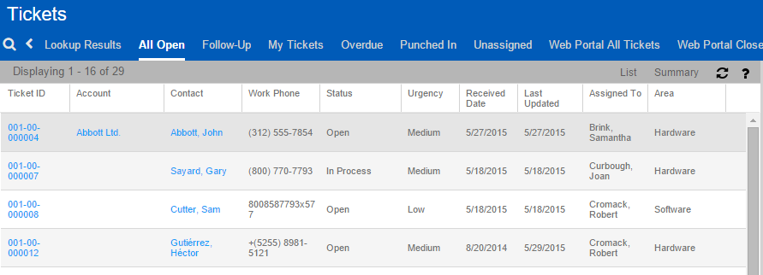

#### Customized Groups for the Ticket module

HHS suggested Group layouts:

|  |  |
| --- | --- |
| Comments: | *HHS ALL Tickets* |
| Group Name: | *HHS ALL Tickets* |
| Conditions: | *HHS All = Owner* |
| Layout (Columns): | *Name, Alert Flag, DOB, SSN, Home Phone, Email, Acct. Manager* |
| Sorting: | *Name Descending* |

|  |  |
| --- | --- |
| Comments: | *JFS Tickets* |
| Group Name: | *JFS Tickets* |
| Conditions: | *HHS All = Owner, JFS = Area* |
| Layout (Columns): | *Name, Alert Flag, DOB, SSN, Home Phone, Email, Acct. Manager* |
| Sorting: | *Name Descending* |

|  |  |
| --- | --- |
| Comments: | *CFS Tickets* |
| Group Name: | *CFS Tickets* |
| Conditions: | *HHS All = Owner, CFS = Area* |
| Layout (Columns): | *Name, Alert Flag, DOB, SSN, Home Phone, Email, Acct. Manager* |
| Sorting: | *Name Descending* |

|  |  |
| --- | --- |
| Comments: | *Confidential Caseload Unit* |
| Group Name: | *Confidential Tickets* |
| Conditions: | *CFS Secure = Owner* |
| Layout (Columns): | *Name, Alert Flag, DOB, SSN, Home Phone, Email, Acct. Manager* |
| Sorting: | *Name Descending* |

## Advanced Groups and Dashboards

TAI will create up to two (2) Dasboards (per SOW) per entity.

This is the “out of the box” Sales dashboard configuration:

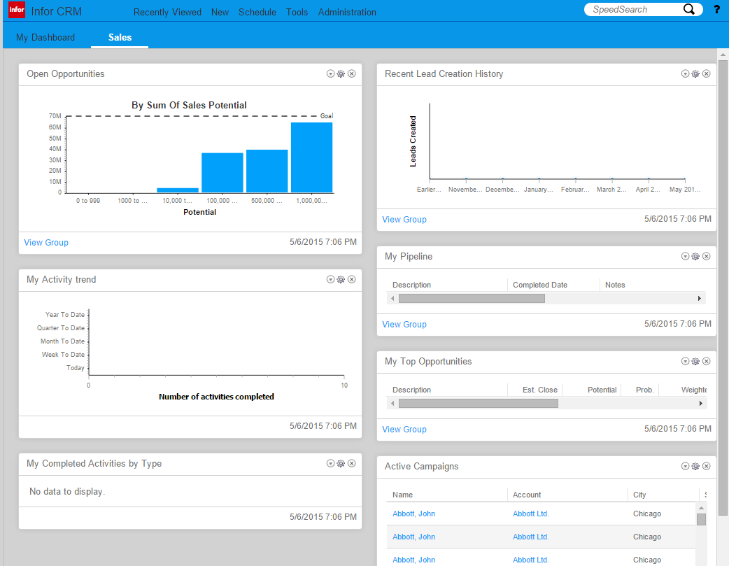

Available Dashlets types in InforCRM:

|  |  |
| --- | --- |
| Dashlet | Description |
| Bar Chart | Displays data as a set of horizontal bars. Useful for comparing several sets of data. |
| Column Chart | Displays data as a set of verticle bars grouped by category. Useful for showing data changes over a period of time or for illustrating comparisons among items. |
| Funnel Chart | Displays data as progressive proportions in a funnel shape. The data is represented as portions of 100%, and ther are no axes. |
| Group List | Displays a list of group records by entity. For example, a group of customer Accounts. |
| Line Chart | Displays data as a series of data points connected by a line. Useful when the data represents many groups or categories. |
| Link | Displays links you create. For example, ta a detail view in InforCRM or to an external Web site. |
| Pie Chart | Displays data as proportion of the whole. Each value is calculated as a percentage of the total. This chart has no axes. |
| Recently Viewed | Displays links to recently viwed records with an icon that identifies the type. For example, Account or Contact. |
| SData Feed | Displays a web feed using SData feeds. For example, a feed from your accounting integration or InforCRM database |
| Today’s Activities | Displays links to your activities for today. |
| Web Feed | Displays RSS or Atom Feed information. |
| Website | Displays a website of your choice. |
| Welcome | Displays an introduction to InforCRM with a link to the help topics introducing InforCRM for web. |

# Email and Outlook integration

Installation of the Xbar and Desktop Integration for InforCRM users will be completed by your internal IT resources. TAI will provide guidance and assistance where necessary.

# Data Import

<Including data source and mapping specs here>

# Approval

Please sign below to approve of the completed work listed in this Blueprint. Customer sign off of the TAI Infor CRM Blueprint will indicate accurate and complete documentation of the project requirements for the Infor CRM system.

***Accepted:***

|  |
| --- |
| **<Client>**  _____________________________________  (Signature)  By: __________________________________  Title: _________________________________  Date: _________________________________ |

# Change Log

|  |  |  |
| --- | --- | --- |
| 12/22/2017 | V1 | Initial Publication for County review |
| 12/28/2017 | V2 | Incorporate County feedback |
| 1/2/2018 | V2 | Per Ursula - Make Opportunity > Repait Type a Multi select pick list |
| 1/4/2018 | V2 | Per Ursula - Add ‘Portfol’ to the Opportunity Status pick list |
| 1/5/2018 | V2 | Per Deb - On the Contact > HHS Detail tab: move from Contact Detail: Spouse, Children, Nationality. Replicate as R/O on the Contact > HHS Detail: Contact ID, Import Source, Create User, Create Date, Modify User, Modify Date |
| 1/15/2018 | V2 | Correct misspellings found during testing |
| 1/17/2018 – 1/25/2018 | V3 | Changes and additions discussed during the Screen Review meetings on 1/16 and 1/17, follow ups with Deb and Ursula on 1/18, and screen changes identified during the JD#2 Security on 1/19. Also JD#2 Security information. Also a new Skills screen mock up. All highlighted in yellow. On 1/25 changes are made in change mode to distinguish what is new as of 1/25/2018. On 1/25 both Sales Processes were replaced. |
| 1/26/2018 | V4 | All V3 highlighting removed. Security updates from JD#2 documented in ch 3, and noted where applied on each entity. Additional screen/field changes in Change Mode. |
| 1/29/2018 | V4 | Security updates updated in ch 3. Additional screen/field changes in Change Mode. |
| 1/31/2018 | V4 | Security updates in ch 3. Changes to SSN on Contact > Detail and Contact > HHS Detail. |
| 2/1/2018 | V4 | Security updates in ch 3. Changes to SSN on Contact > Detail and Contact > HHS Detail. |
| 2/2/2018 | V4 | Security updates in ch 3. Updates to Skills entity to remove pick lists, and SkillUp tabs to remove Skill Name field. |
| 2/5/2018 | V4 | Correct Team label from JFS SUP to WI All. Also refer to the provided user spreadsheets for specific users on teams and roles. |
|  |  |  |
|  |  |  |